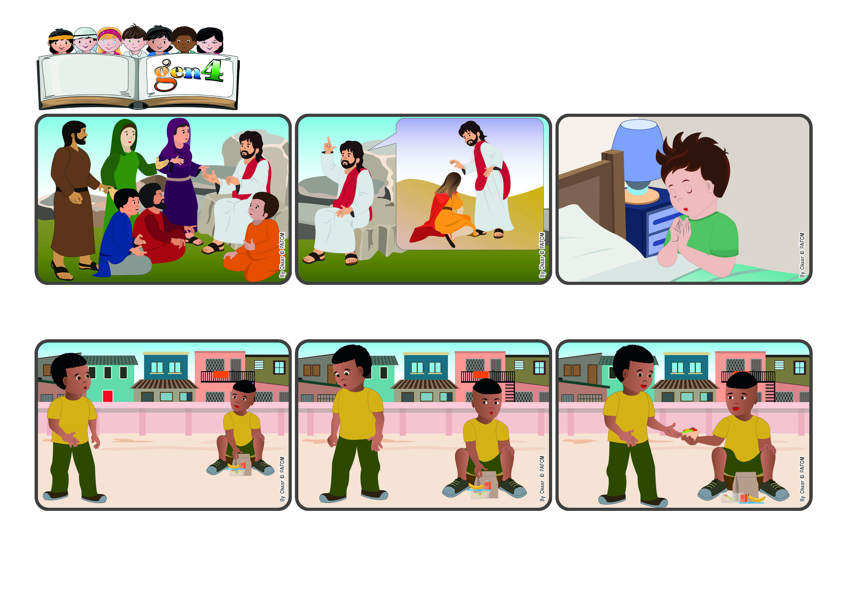

(**March 2024**, From the liturgy of Sunday Mass, March 17, the fifth Sunday of Lent.)

**“Create in me a clean heart, O God, and put a new and right spirit within me.” (Ps 51:10)**

**Give us, O Lord, a pure heart to love others!**

**Word**

**of Life**

**One day during recess at school I was eating the snack my mom had prepared for me. Then when I looked up I realized that my friend had no snack with him and was a little sad.**

**But Jesus explained that he had come to help, to welcome people and listen to them. He came to serve and not to rule over them like a tyrant. It’s not easy to live like Jesus! But we can try and if we do, we will have eternal life that will never end.**

**Many people wanted to know Jesus and listen to him. They understood that he was an important person. Many of them believed he was the powerful and strong king they had been waiting for.They hoped he would free them from the people who oppressed them.**

**But for this to happen, we have to have a pure heart and sincerely listen to his words. Let’s ask him for it! “Give us, O Lord, a pure heart to love others!” Jesus will help us to be strong even when it’s hard. He will teach us how to bring love into the world like he did.**

**But then I couldn’t manage to eat it alone! So I called him back and shared with him what I had. He thanked me very much, but in my heart I felt even happier than him because I had loved Jesus in my classmate.**

**(Ashon, Ivory Coast)**

**I pretended that I didn’t notice, but then he actually came up to me and asked if I could share my snack with him. I said “no!” because I was really hungry! So he went away without saying anything.**

**© PAFOM, Drawings and text provided by the Gen4 Center.**

**The Gen4 are the young children of the Focolare Movement, which was founded by Chiara Lubich.**