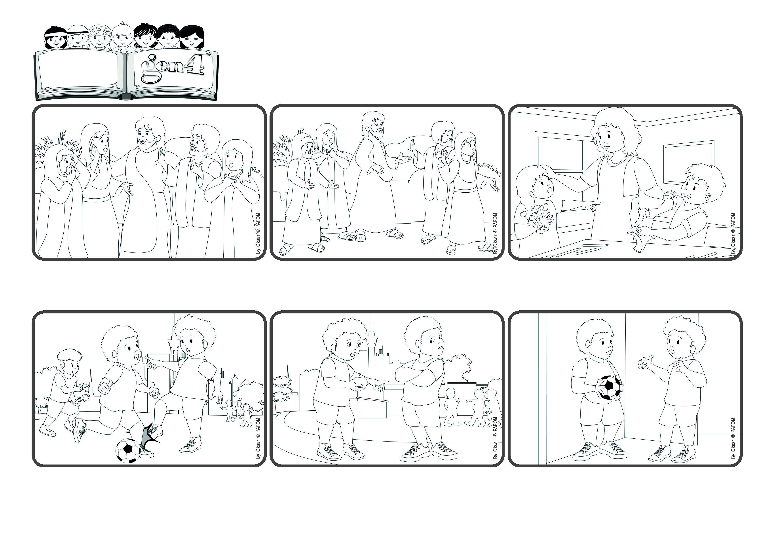

**«Why do you see the speck in your neighbor’s eye,**

**but do not notice the log in your own eye?» (Lk 6:41)**

(From the liturgy of March 2, the 8th Sunday in Ordinary Time)

**“Let’s help each other to start over”**

**Word**

**of Life**



***But Jesus is right! It’s so easy to see the failures of other people and ignore our own. Let’s help one another not to judge others, to start over again all the time and to welcome with love those who fail, just like a mother would!***

***Many people were following Jesus because they liked listening to him. But sometimes he said things that were hard to understand. One day he told them to love their enemies, to do good to other people, without expecting anything back. But who is able to do that?***

***Jesus also said: “Don’t judge others, forgive them!” Many of the people thought, “No, this is not for me!” But he kept talking and gave them a strong example – he spoke of having a log in your eye and yet looking at the speck in another person’s eye!***

***One day he knocked at the door of my house. He had come to ask if we could play together again! I was so happy!! Ever since then, we went back to loving one another like brothers. (Pierre from Congo)***

***I was very sad and also upset with him because he wouldn’t accept my apology. Then I thought of what Jesus said: “Love your enemy!” So, even though he kept ignoring me, I started helping him in little ways.***

***I have a friend and we play soccer together. One day, during a game, I hit him on the leg by mistake. He got really mad and refused to talk to me, even though I said I was sorry.***

**© PAFOM, Drawings and text provided by the Gen4 Center.**

**The Gen4 are the young children of the Focolare Movement, which was founded by Chiara Lubich.**