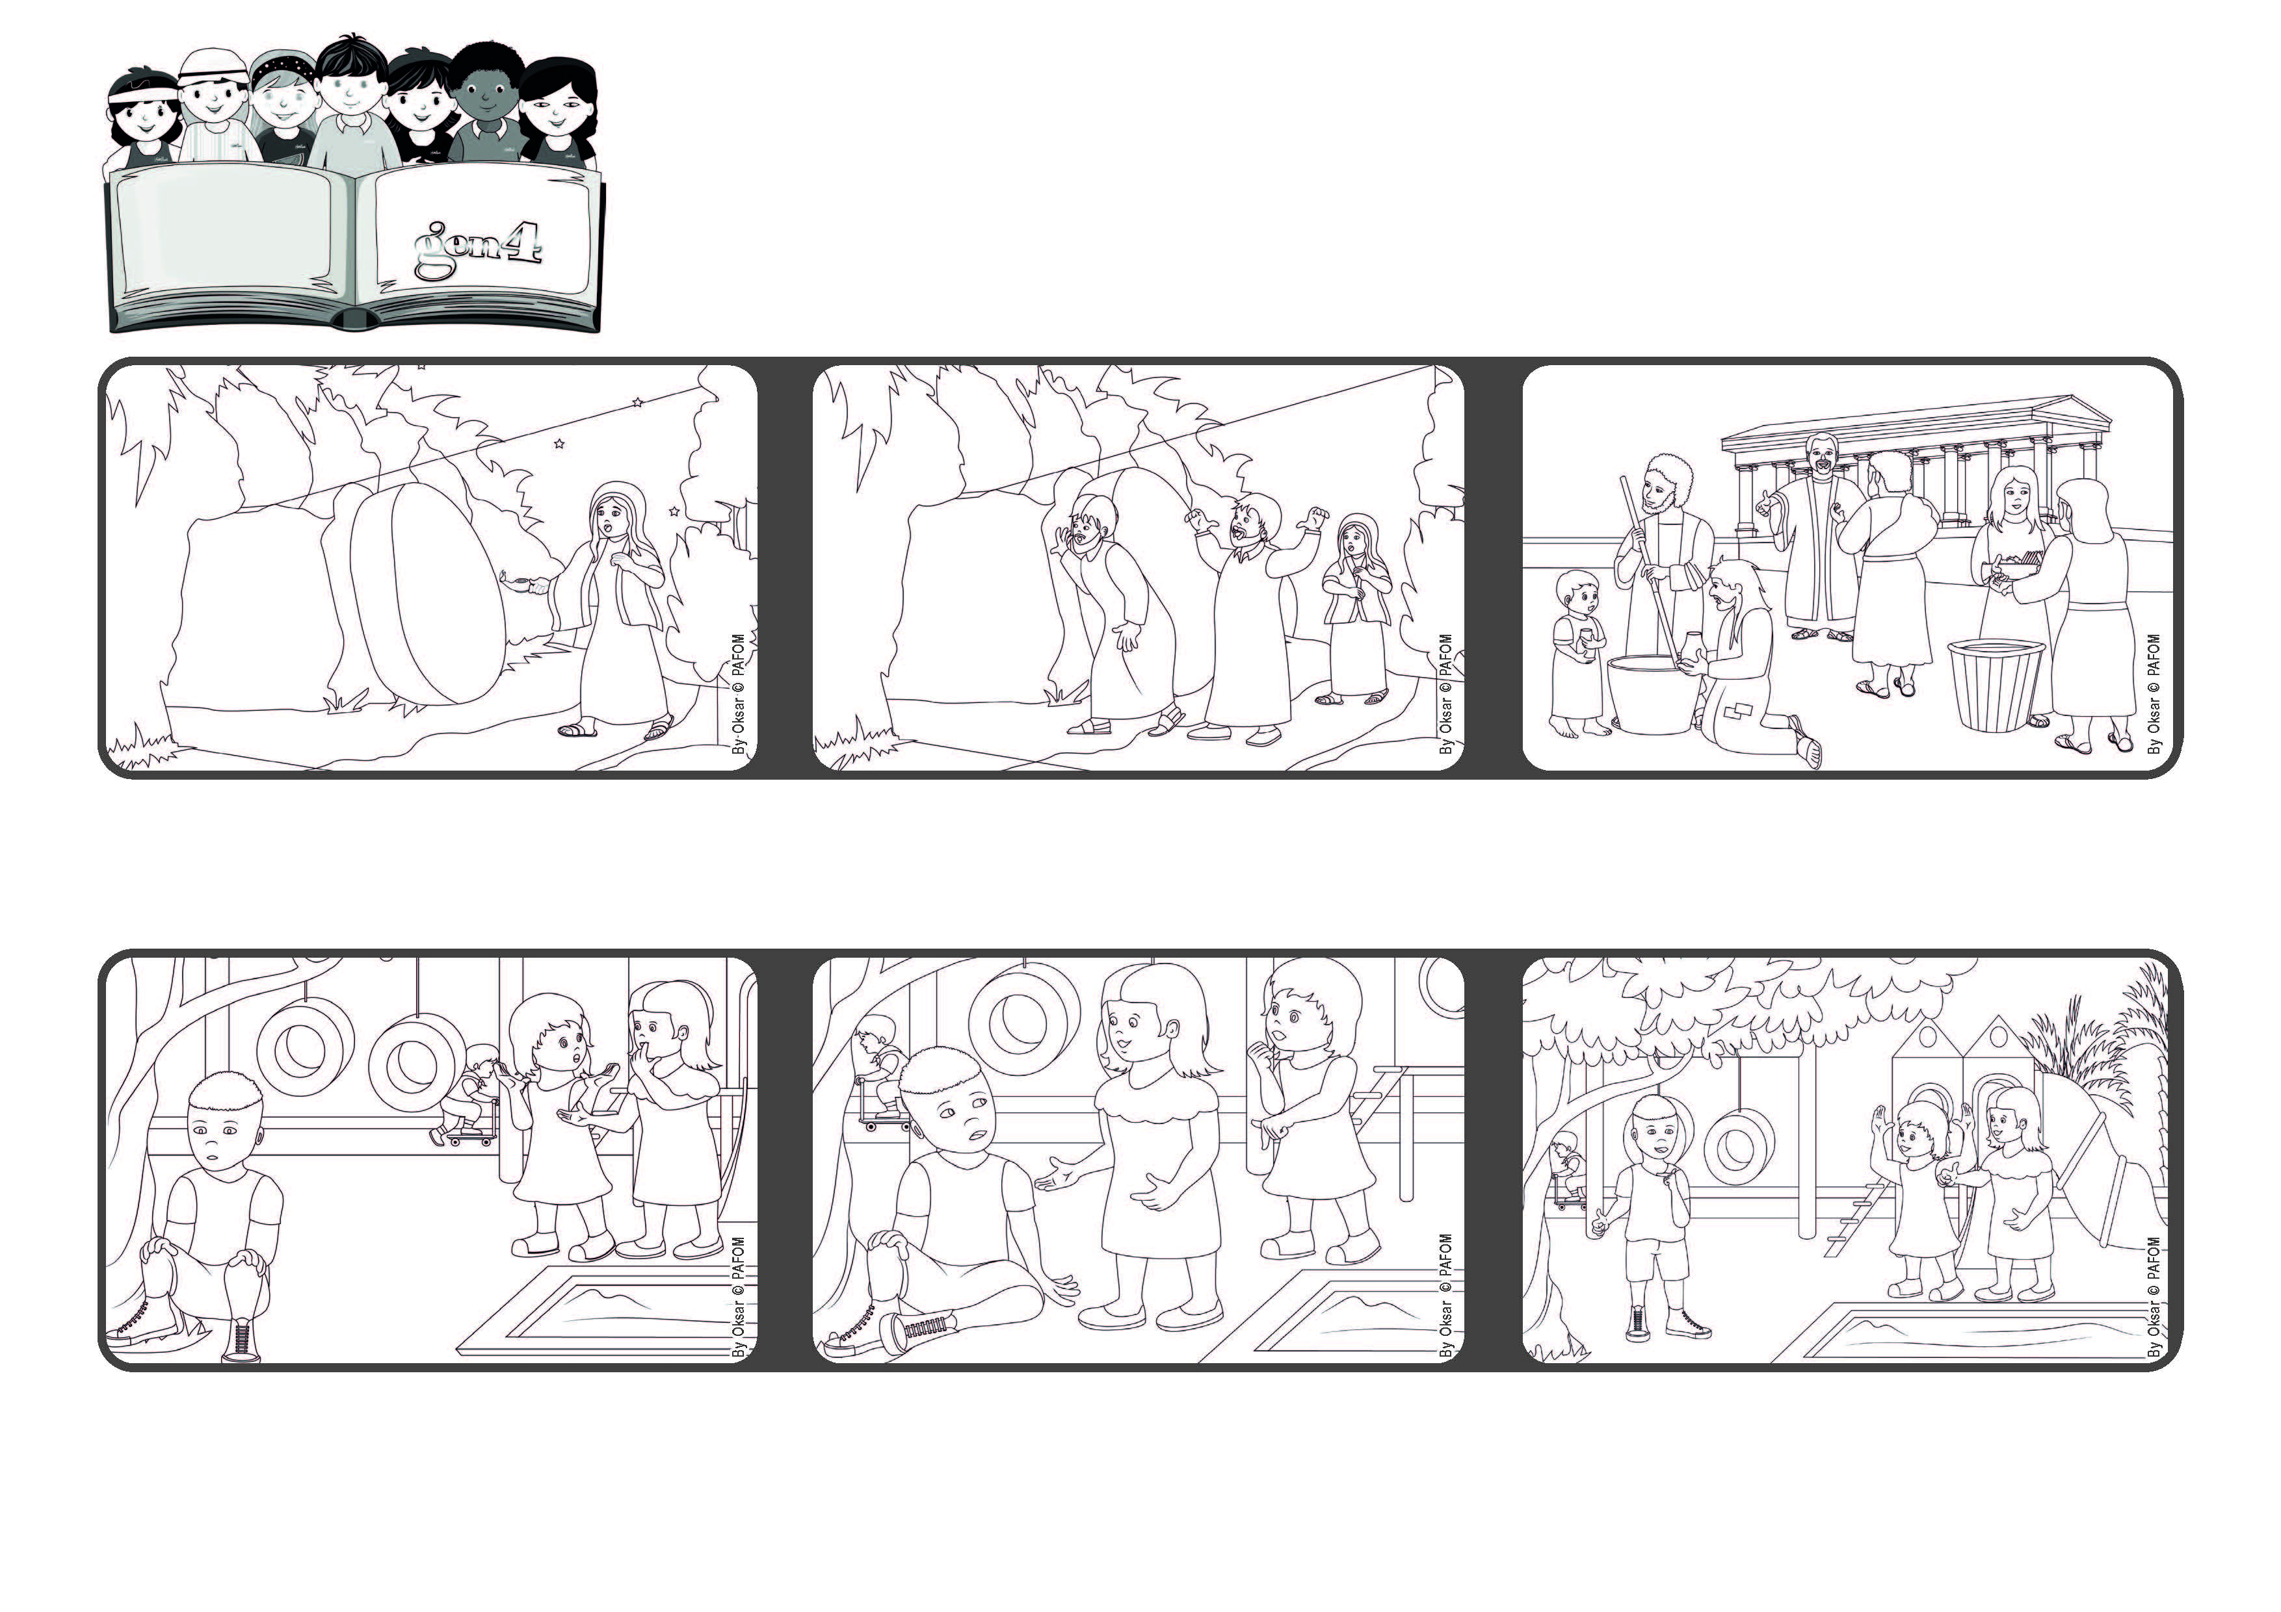

**“Set your minds on things that are above, not on things that are on earth.” (Col 3:2)**

**(from the prayers at Easter Sunday Mass)**

**The Risen Jesus helps us to love,**

**which is the law of heaven**

**April 2023**

**Word of Life**



**The next day Luisa saw Maria Chiara in the park and told her: “I understood that you were right. It’s much nicer if we all play together!” So they went to get Marco and they all had a lot of fun together with the other children.**

**Many years later, in one of his letters, the Apostle Paul reminds Christians that Jesus rose from the dead and he helps us to live the law of heaven, which is to love.**

**Very early in the morning, when it was still dark, Mary Magdalene went to the place where Jesus had been buried. She got a surprise! The huge rock in front of the tomb had been rolled away!**

**She ran back right away to tell Peter and John. They ran to the tomb and saw that the body of Jesus wasn’t there anymore. So they understood that he had risen from the dead!**

**Luisa, her best friend, got very angry about it and decided not to talk to her anymore. Maria Chiara was sad. It felt like she had a big stone on her heart, but she felt she had done the right thing.**

**Experience of Maria Chiara from Italy: At the park no one was talking to Marco because they thought he wasn’t very nice. But Maria Chiara wanted to play with everyone, including Marco.**

**© PAFOM, Drawings and text provided by the Gen4 Center.**

**The Gen4 are the young children of the Focolare Movement, which was founded by Chiara Lubich.**