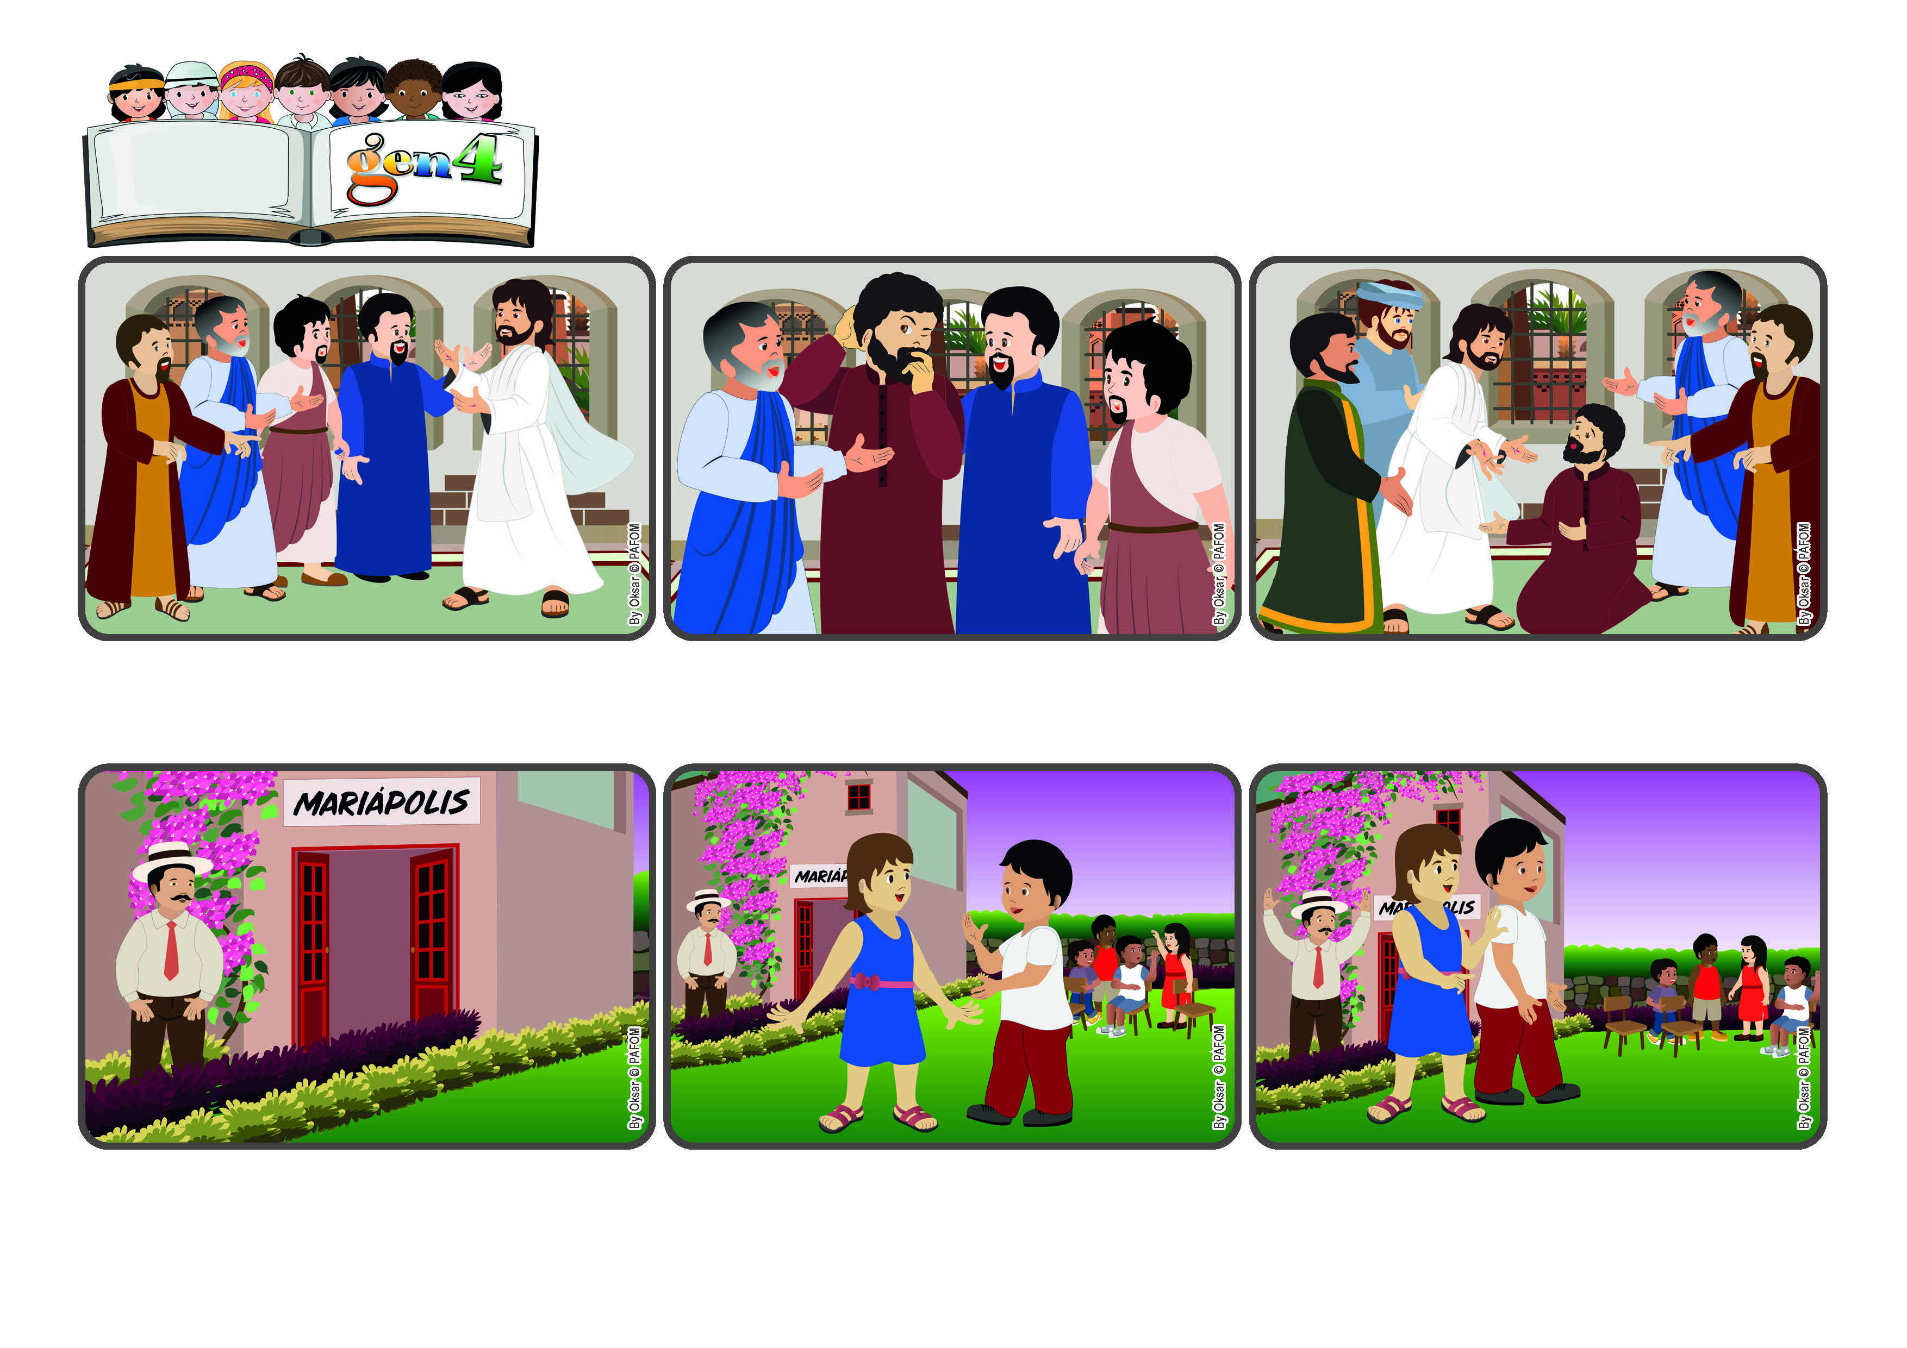

(**April 2024**, From the liturgy of The Sunday Mass on April 7 in the Season of Easter.)

**“ With great power the apostles gave their testimony to the resurrection of the Lord Jesus, and great grace was upon them all.” (Acts 4:33)**

**Let’s bring the joy of the Risen Jesus to everyone.**

**Word**

**of Life**

**© PAFOM, Drawings and text provided by the Gen4 Center.**

**The Gen4 are the young children of the Focolare Movement, which was founded by Chiara Lubich.**

**Mariapolis is a meeting of several days when people live the Gospel together and put into practice the new commanement: “Love one another.”**

**A few days later, Jesus came back and with great love told Thomas: “Here, put your finger in my wounds!” Thomas exclaimed: “My Lord and my God!” Yes, Jesus is truly risen! Let’s bring his joy to everyone!**

**That’s how it was for Thomas, one of the apostle who had not been present when Jesus appeared to them. “I won’t believe until I see him with my own eyes and put my finger in the wound of the nails.”**

**There was a Mariapolis in Colombia and there were many people, including children and adults who were all trying to live the law of love. One man, who had never been to a Mariapolis, didn’t want to go into the hall and instead walked around the yard.**

**What great joy! Jesus in risen! Some women and the disciples actually saw him and they were so happy that they told everyone they met. But for those who had not seen him themselves, it was very hard to believe that he had really risen from the dead.**

**The girl looked at him and smiled and they happily went back to play with all the others. The man who had been watching them was deeply touched by that. He said, “Now I have really seen mutual love in practice!” The Gen 4 had shown him by their witness.**

**He saw many Gen 4 who were playing together. At a certain point one girl got upset and left the group. The other children stopped playing and looked at one another. Then one Gen 4 boy ran over to her and told her: “I’m sorry! Will you forgive me?”**