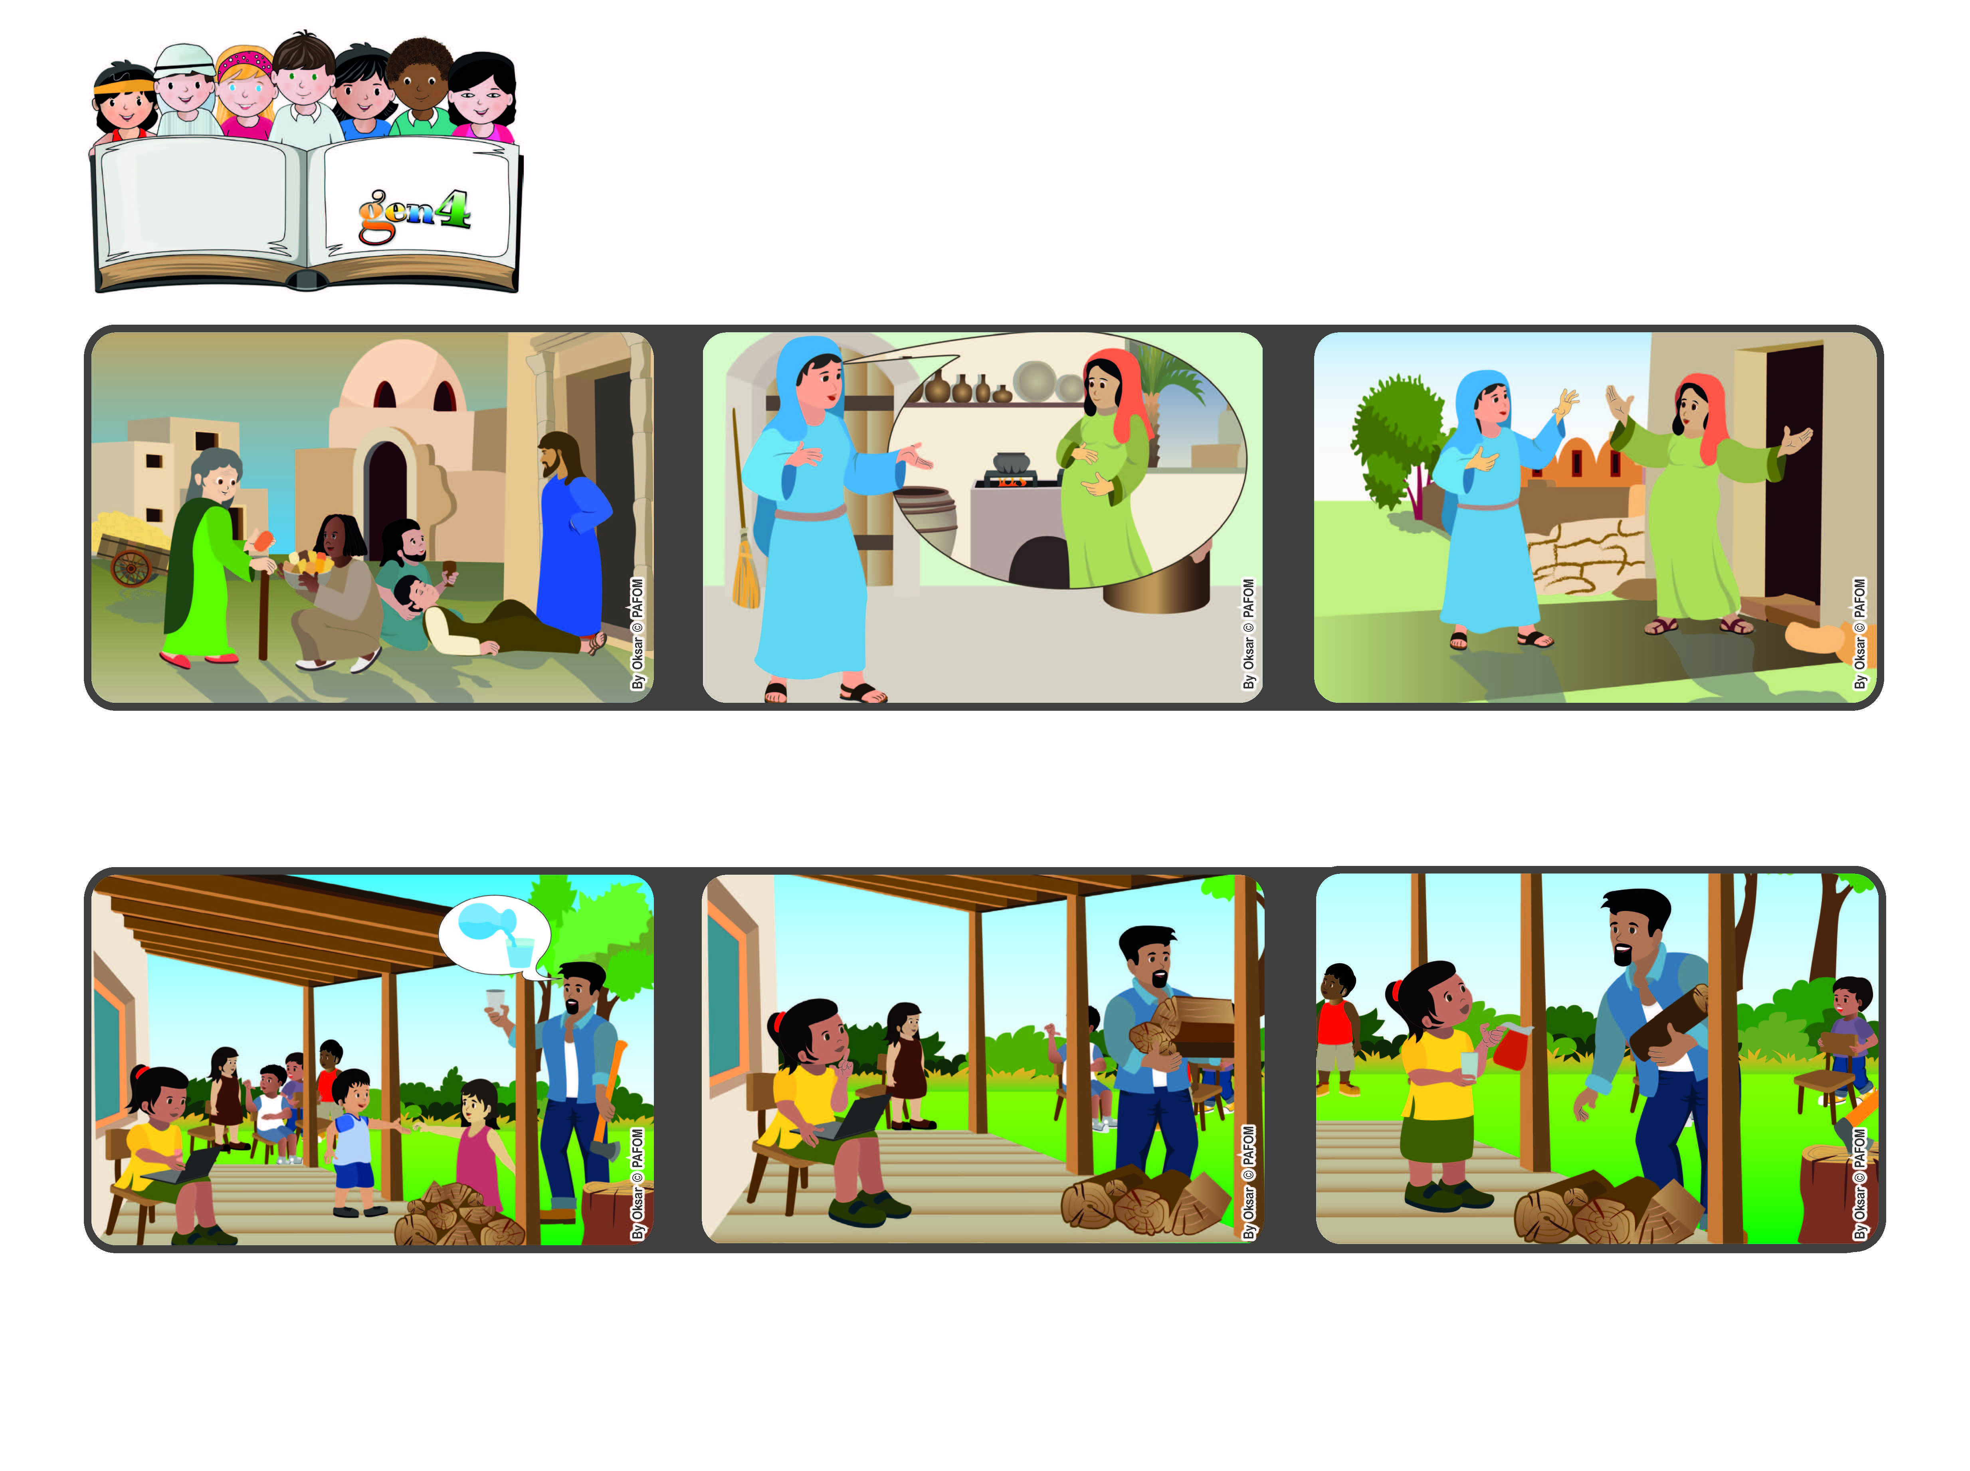

**Word of Life**

**May 2023**

**Let’s compete in loving!**

**Love one another with mutual affection; outdo one another in showing honor.” (Rm 12:10)**

**(from the Mass of the Visit of Mary to Elizabeth, May**

**But then I thought that my Dad needed help because he couldn’t move at that moment. So I got up and I was really happy to bring him a glass of water.”**

**…who was also expecting a baby, even though she was already quite old. Mary immediately started off on a trip to visit her and help her. Mary taught us to be the first to love everyone!**

**In one of his letters to the first Christian communities, Saint Paul encouraged them to love one another and to compete to see who could love the most.**

**That’s what Mary, the mother of Jesus did. When she heard from the angel that she would have a child, she didn’t think of herself but remembered her cousin, Elizabeth….**

**None of us listened to him, because we were all busy doing other things. I was doing my homework and I didn’t feel like interrupting it, because I wanted to finish quickly so I could go out and play.**

**Beatriz from Brazil shared this experience: “In my family there are many children and my parents often ask us to help them. One afternoon my father asked someone to bring him a glass of water.**

**© PAFOM, Drawings and text provided by the Gen4 Center.**

**The Gen4 are the young children of the Focolare Movement, which was founded by Chiara Lubich.**