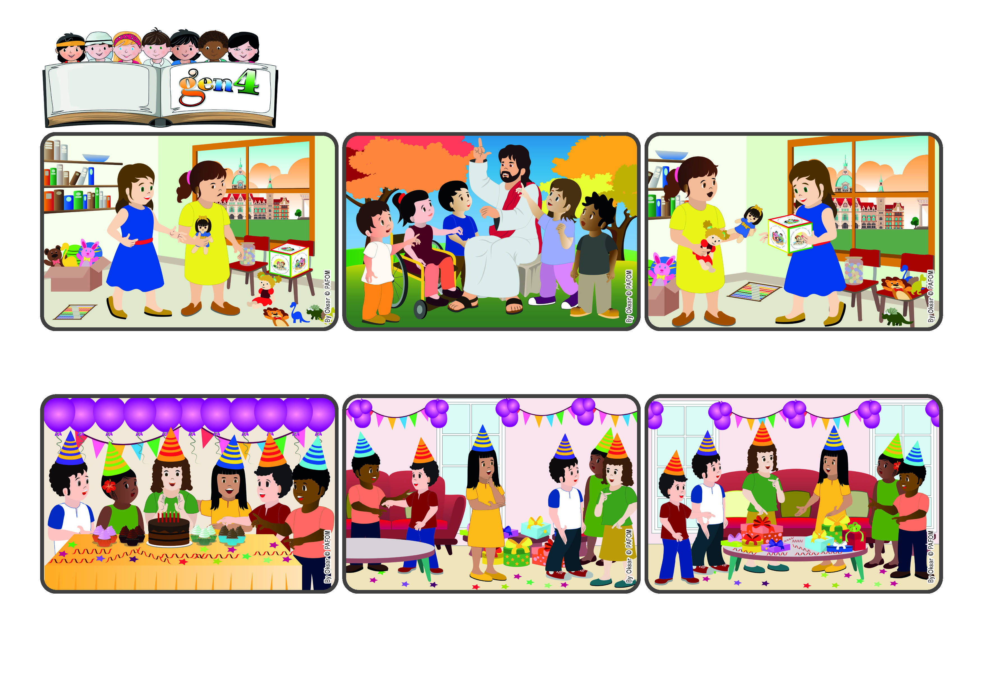

**Whoever loves, knows God**

**“Whoever does not love, does not know God, for God is love” (1Jn 4:8).**

(From the liturgy of May 5th, the Sixth Sunday of Easter)

**Word**

**of Life**

Jesus helps us because he often speaks about the love of God, his Father. He and his father love one another in a very special way and Jesus wants to share this love with all of us. In fact, he calls us his “friends.”

Have you ever been a little jealous because your friend has something you don’t have? Or do you envy your brother or sister? And perhaps you don’t always want to share the nice things you have?

I put all the presents on the table in the living room and divided them evenly – half for her and half for me. When I gave them to her, my friend was really surprised and very happy. And I was happy too that she felt our love!

My friend certainly didn’t expect that! At the end of the party, when I saw my gifts, I realized I had many of them, but she had none. I immediately decided to share my gifts with her so as to love her.

Maria from Brazil wrote: At my birthday party, one of my friends came and it was her birthday too! When it came time to cut the cake, I asked my mom to sing “Happy Birthday” to her first and then to me.

**© PAFOM, Drawings and text provided by the Gen4 Center.**

**The Gen4 are the young children of the Focolare Movement, which was founded by Chiara Lubich.**

He even gave us the secret to know God, who is his Father but also our Father. The secret is to love! Rolling the “cube of love” can give us ways to love every day, just like God loves us.