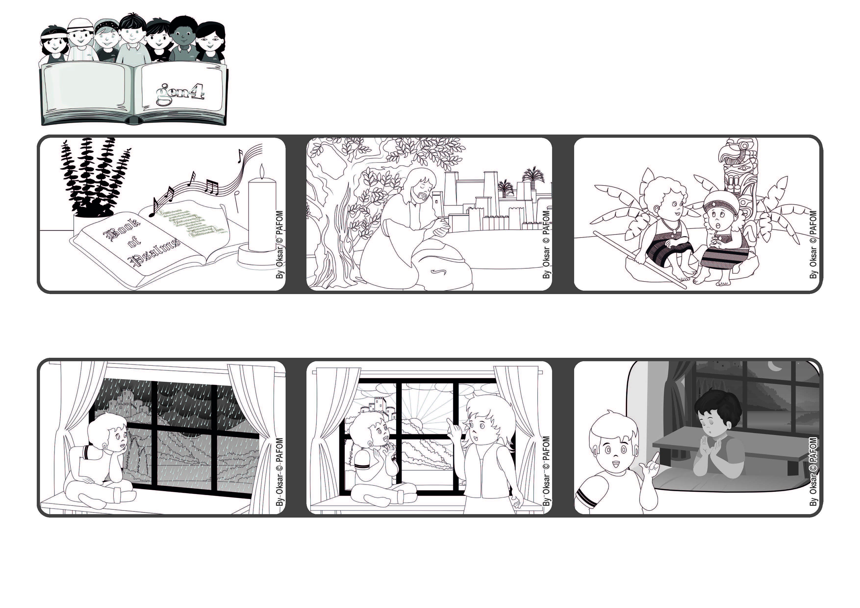

Word of Life
June 2022
“You are my Lord; I have no good apart from you.” (Ps 16:2)
Jesus, what can I do for you today?
Do you think it’s because every night before I go to sleep I tell him that I love him very much? Francesco from Italy
After a few moments I called my mother and told her, “Look at the sun peeking out from behind the clouds! It’s really such a nice gift that Jesus is giving me!”
One day I was looking out the window and saw that it was raining a lot and there were lots of gray clouds.
When we love people around us, it helps us to experience God’s presence in our hearts and we feel like talking to him. God never leaves us alone.
Jesus also taught us how to pray, telling us that God is a kind Father who loves everyone.
In the book of Psalms in the Bible, there are some beautiful prayers. One of them says: “You are my Lord; I have no good apart from you.”
© PAFOM, Drawings and text provided by the Gen4 Center.
The Gen4 are the young children of the Focolare Movement, which was founded by Chiara Lubich.

