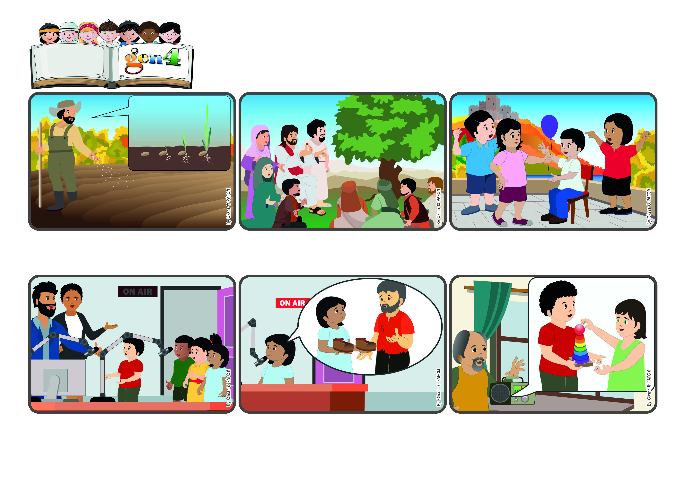

**Word**

**of Life**

(From the liturgy of June 16, the Eleventh Sunday in Ordinary Time)

**“The kingdom of God is as if someone would scatter seed on the ground, and would sleep and rise night and day, and the seed would sprout and grow” (Mk 4:26-27).**

**Let’s make love grow in us**

**Francisco said that he lent his toys to his little sisters. At the end of the program, the people who work at the radio station thanked them. Their little stories had gone far and wide and gave joy to many who listened in! (The Gen 4 of El Salvador)**

**Carmen took a mic and said: “I gave my doll to a friend who didn’t have any toys.” And Susana said: “I wanted to help a little girl who had no shoes. I was so happy when I could give her a brand new pair that my uncle sent to me!”**

**The Gen 4 are excited to be invited to speak on the radio! “We have to prepare ourselves well,” they told one another. On the day of the program, when they got to the studio, everything was ready. There were many microphones but the Gen weren’t scared.**

**The branches of this tree become so big that the birds in the sky can rest on its branches and make their nests in its shade. This is the same for every act of love we do! Even though it is something small it can bear much fruit and give joy to many people!**

**Jesus often explained that the new life he came to bring on earth is like that very tiny seed. It is small but very strong and it grows without making any noise. It can become a tree that is bigger than all the plants in the garden.**

**Have you ever seen a farmer throw seed on his fields? He doesn’t see it anymore, but the seed is gradually transformed. It sends out little roots and then a little stem breaks through the soil and grows into a big plant.**

**© PAFOM, Drawings and text provided by the Gen4 Center.**

**The Gen4 are the young children of the Focolare Movement, which was founded by Chiara Lubich.**

**Mariapolis is a meeting of several days when people live the Gospel together and put into practice the new commanement: “Love one another.”**