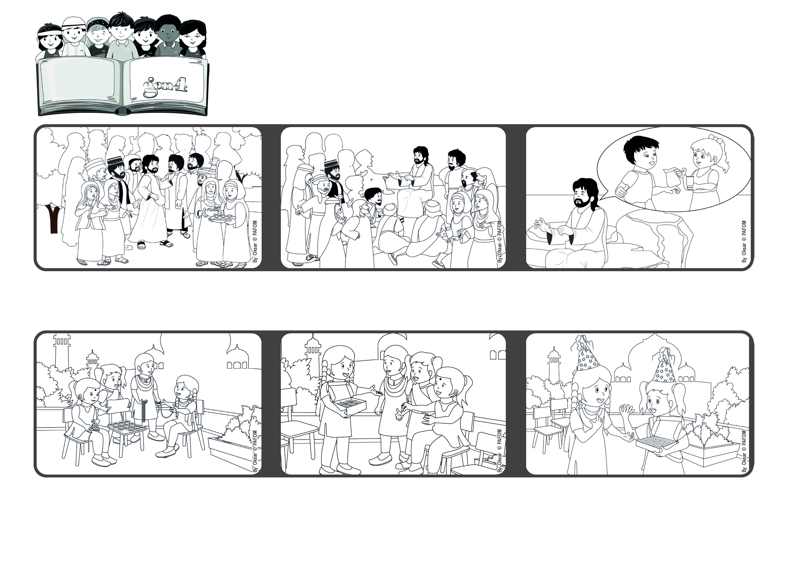

**“Whoever gives only a cup of cold water to one of these little ones to drink because the little one is a disciple - amen, I say to you, that person will surely not lose their reward.” (Mt 10:42)**

(From the Mass of the thirteenth Sunday in ordinary time)

**Let’s love by taking care of people**

**July 2023**

**Word of Life**



**One day Ajala came with a big box of little round beads of many colors! Everyone was so excited! That day Ajala went home very happy because she had given a gift to Jesus. But then she thought: “But now I don’t have any for myself!”**

He gives an example. Even if someone gives a glass of water to one of the youngest children they will have a reward. Yes, becuase water is important for people to live. Jesus loves by paying attention to the needs of people and we have to do the same. Then Jesus will be pleased with us!

Many people wanted to hear what Jesus was saying. The 12 apostles whom he especially chose, are always with him. But there are also many other people who wanted to get to know him. And Jesus, too, wanted them to hear his message.

So he taught his disciples how to love everyone as he loves them. Visiting all the cities and towns, they should share his teachings with anyone who welcomed them into their homes.

**Some time passed and it was her birthday. A friend brought a big package as a gift. It was full of many little beads shaped like flowers! She had been generous and Jesus was generous with her!**

**Ajala lives in India. With her friends they decided to collect money to help the poor people. So they started making little necklaces to be sold.**

**© PAFOM, Drawings and text provided by the Gen4 Center.**

**The Gen4 are the young children of the Focolare Movement, which was founded by Chiara Lubich.**