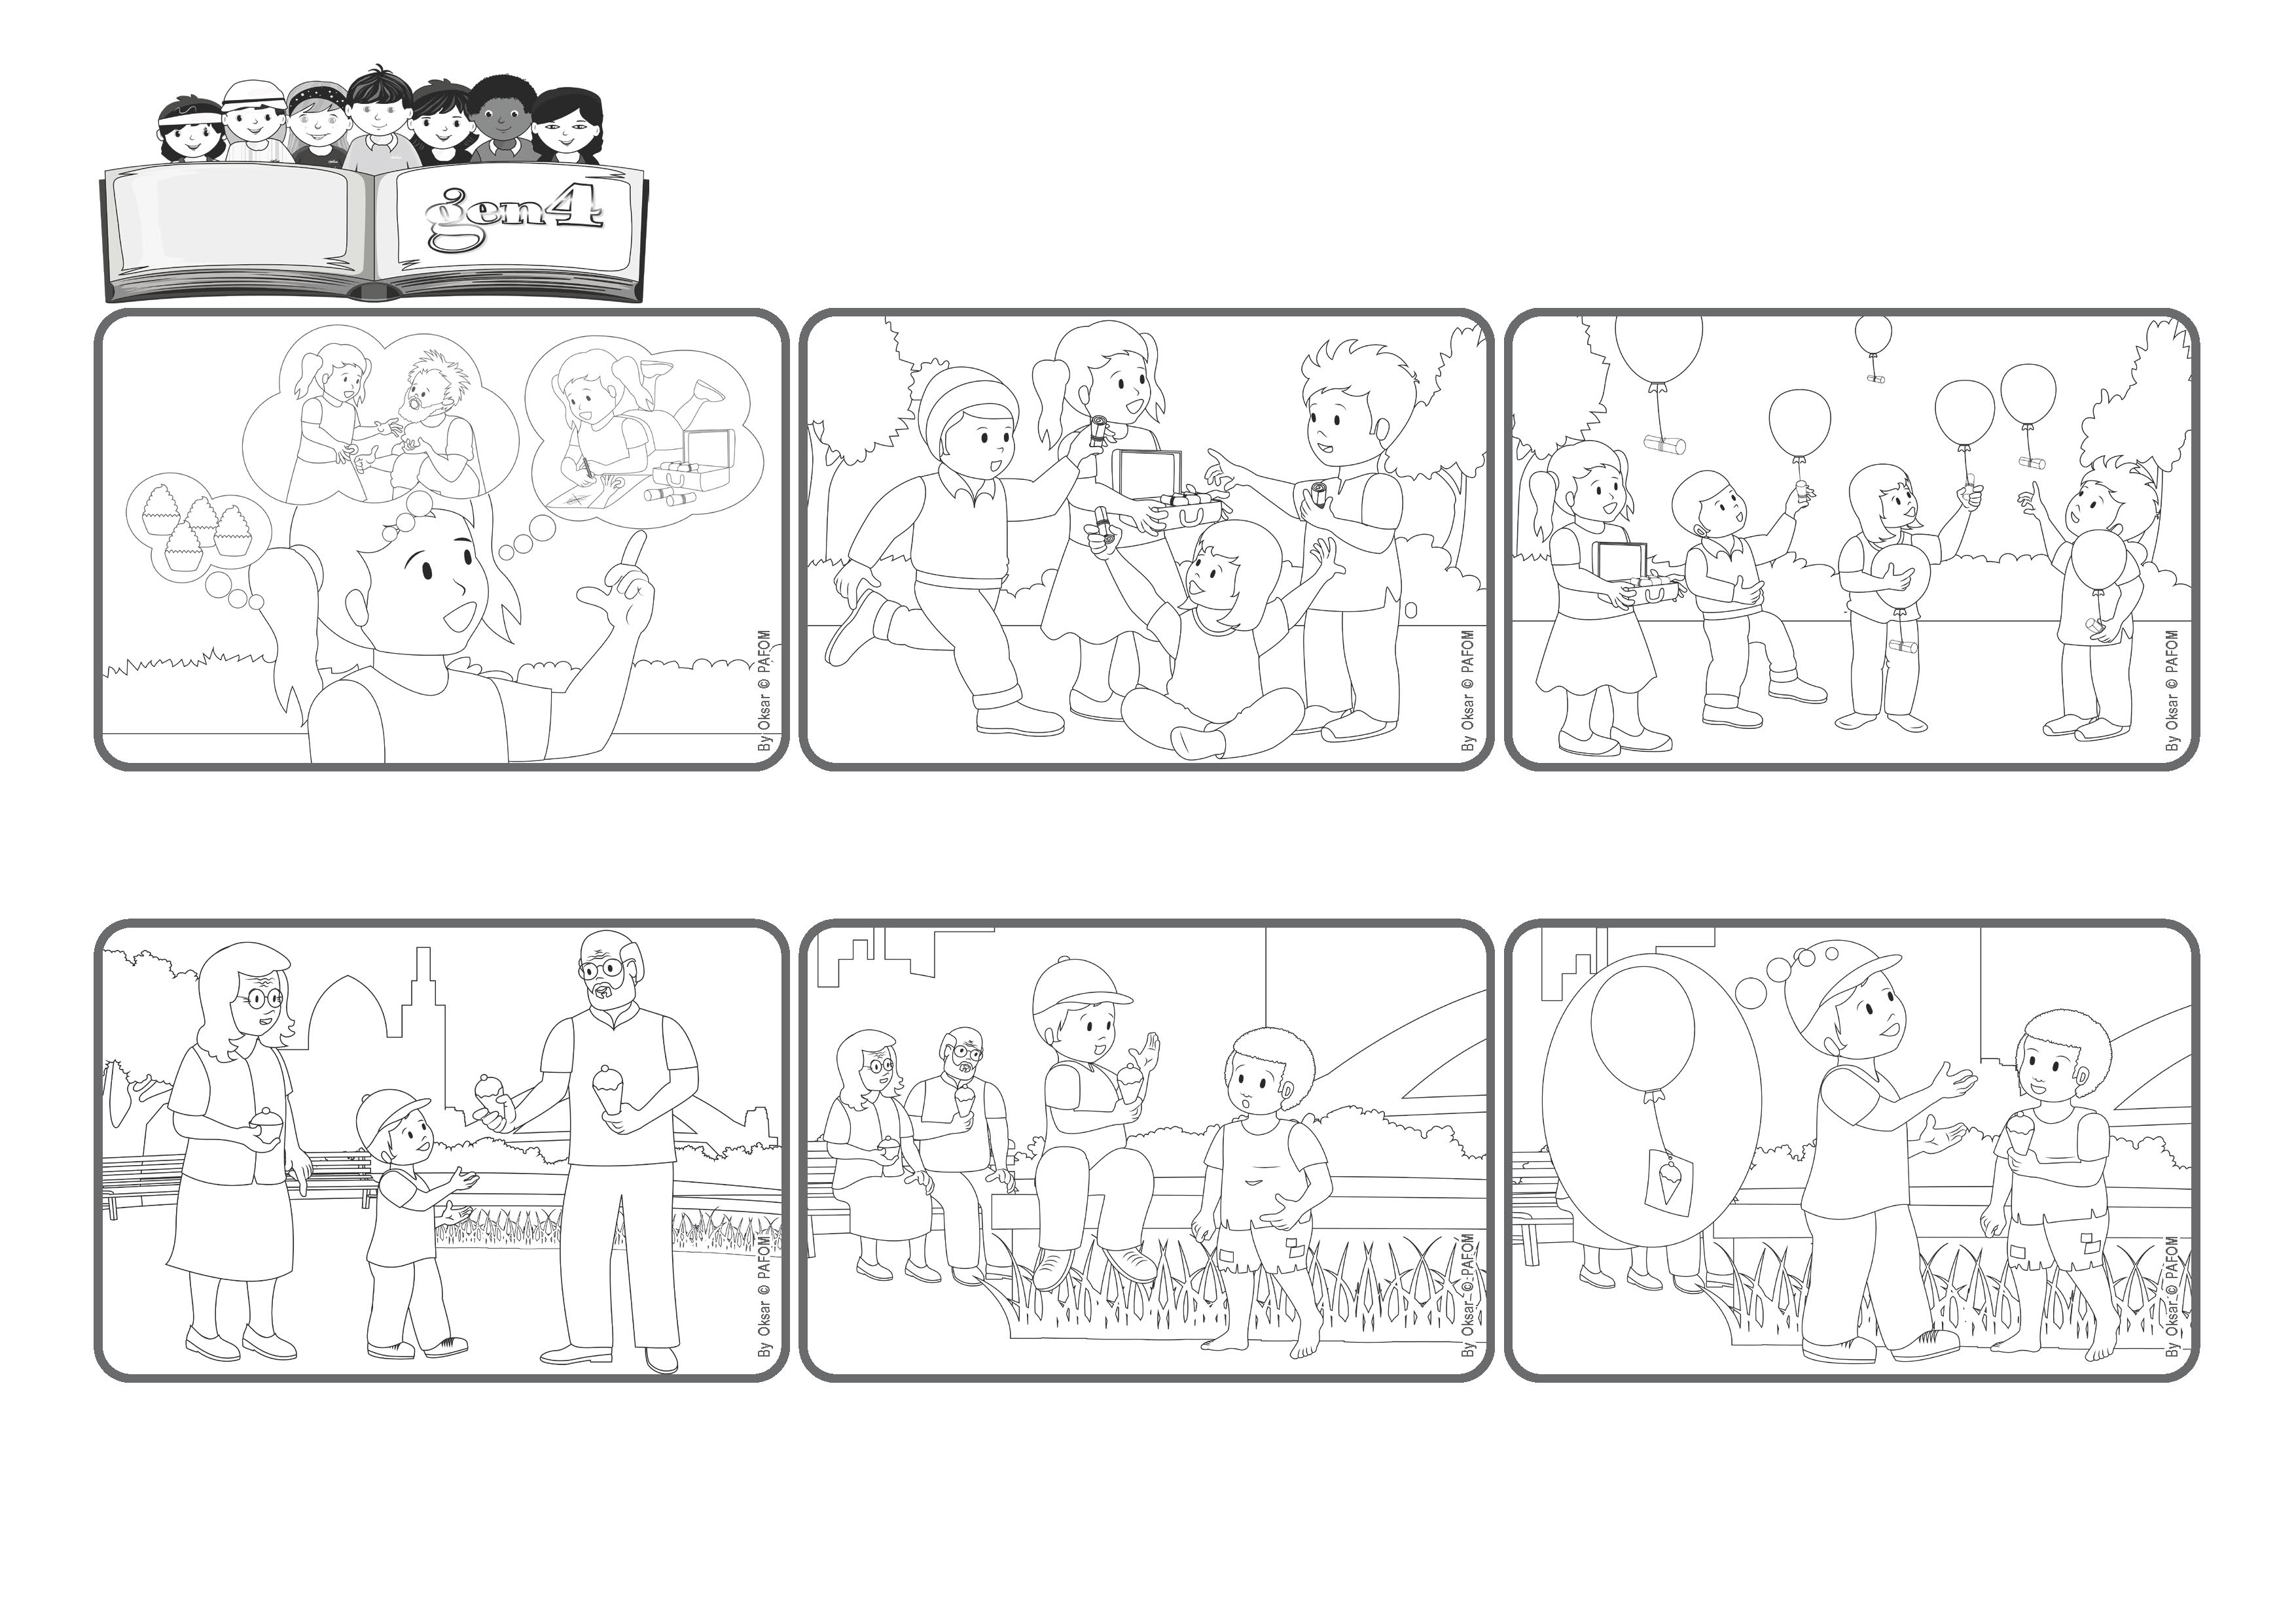

**Word**

**of Life**

**Our real treasure!**

**Let’s fill our hearts with acts of love!**

**«For where your treasure is, there your heart will also be» (Lk 12:34).**

(From the liturgy of August 3, 2025, the 18th Sunday of Ordinary Time)



**Jesus came down from heaven and so he knows very well what is important for us to do so we can go to heaven with him. A lot of money, or nice food, or beautiful clothes are not necessary. Instead, we need a suitcase full of very special packages – all our acts of love!**

**My grandparents were sitting on a bench talking and I sat on a nearby wall. I was just about to start eating my ice cream when I looked up and noticed a little boy standing in front of me.**

**He was very little, and I wanted to send him away, but then I remembered the picture of Jesus saying, “You did it to me.” And so, I gave him my ice cream cone. He was so happy! I too felt joy in my heart because I had made a package for Jesus.**

**When we take a trip, we carefully prepare our suitcase. We can’t take a lot of things with us, so we have to choose what is most important. It’s the same way in our life – we have to choose what is the most important thing to do.**

**My name is Marco and I’m 7 years old. During the summer I often go to spend a few days with my grandparents. One day, since I had been very good, they took me out and my grandfather bought me an ice cream cone.**

**The packages we prepare for Jesus – like sharing our toys or giving someone a piece of our candy – these are the golden coins we will bring into heaven. That’s what Jesus meant when he said: “Where your treasure is, there your heart will also be!”**

**© PAFOM, Drawings and text provided by the Gen4 Center.**

**The Gen4 are the young children of the Focolare Movement, which was founded by Chiara Lubich.**