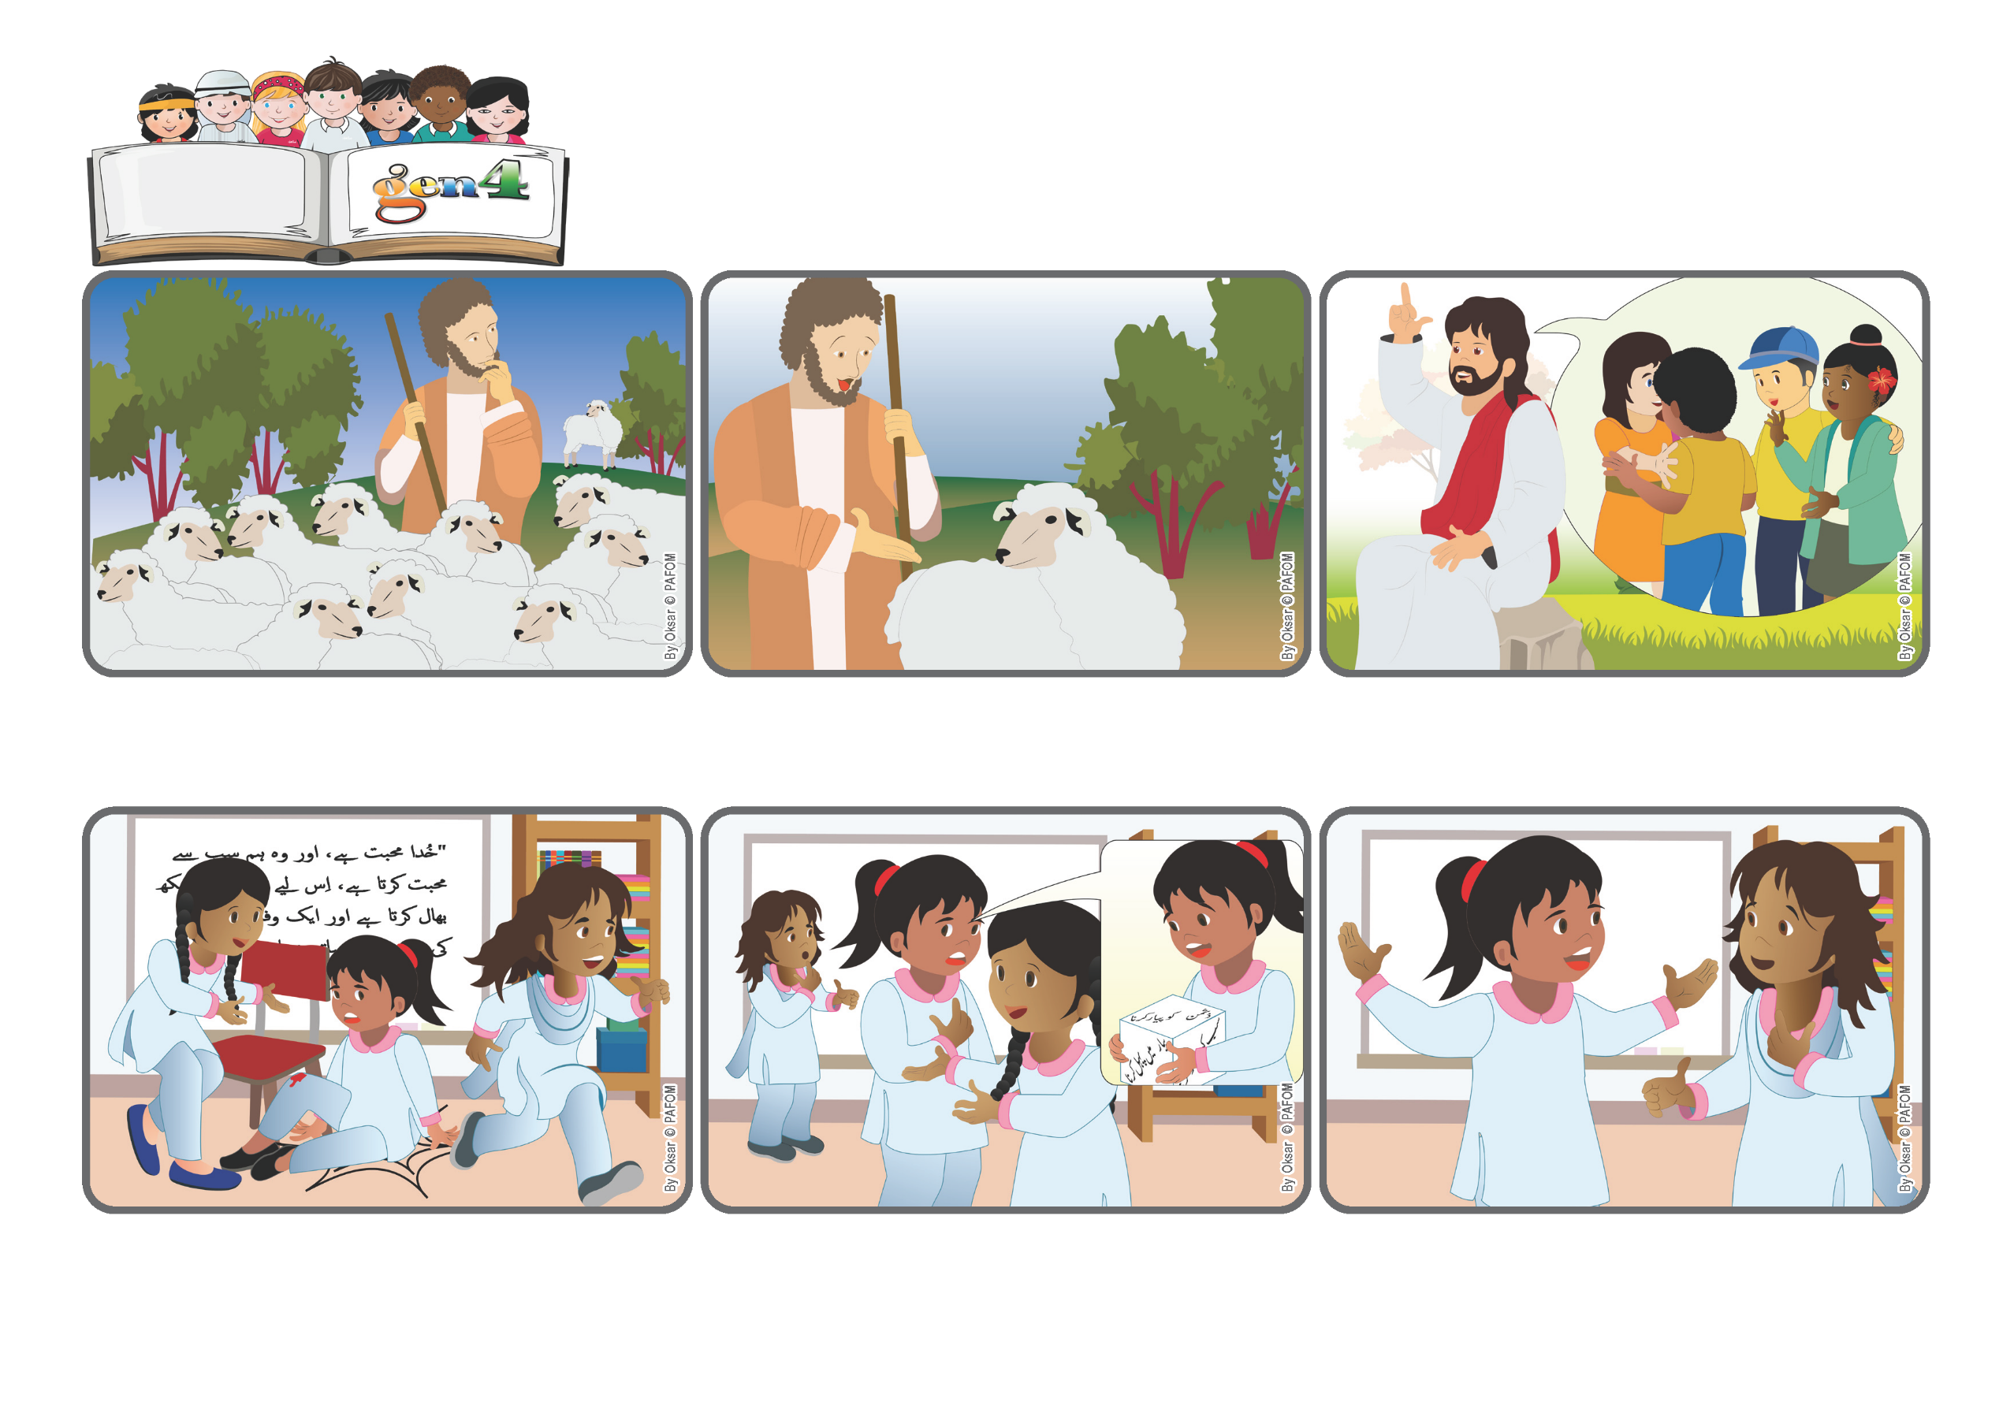

**Word**

**of Life**

**«Rejoice with me, for I have found my sheep that was lost.» (Lk 15:6).**

(From the liturgy of September 14, the 24th Sunday in Ordinary Time)

**Jesus forgives us and helps us to forgive others**

**I had a lot of friends, why did I need her? It was very hard for me, but the next day, when I went into the classroom, I didn’t go up to the group of my friends, but instead I went over to where she was all alone – and I gave her a big hug!**

**I was really angry with her. She became my “enemy” and I never spoke to her again. However, one day at home I was tossing the Cube of Love and what came up was “Love your enemy.” I understood that I had to make peace with her...but I really didn’t want to!**

**My name is Zaira and I’m from Pakistan. I have many friends at school but there are some girls who aren’t very nice. One day one of them came running into the door and knocked me down. I hit a chair and hurt myself.**

**“Do you understand?” Jesus asked the people who were listening to him. “There is more celebration in heaven when one person who has done bad things repents and goes back to doing good, than for all the others who only think of themselves and don’t want to start over again.”**

**He was very worried and looked all around...but he couldn’t see it. What should he do? He had no doubt! He left the other 99 sheep alone to graze and went out to find the one that was lost. He was full of joy when he found it and went home to celebrate!**

**Every day the shepherd took his hundred sheep out to the pasture and watched over them with love. He was careful not to lose any of them. However, one day when he was going home, he realized that one was missing!**

**© PAFOM, Drawings and text provided by the Gen4 Center.**

**The Gen4 are the young children of the Focolare Movement, which was founded by Chiara Lubich.**