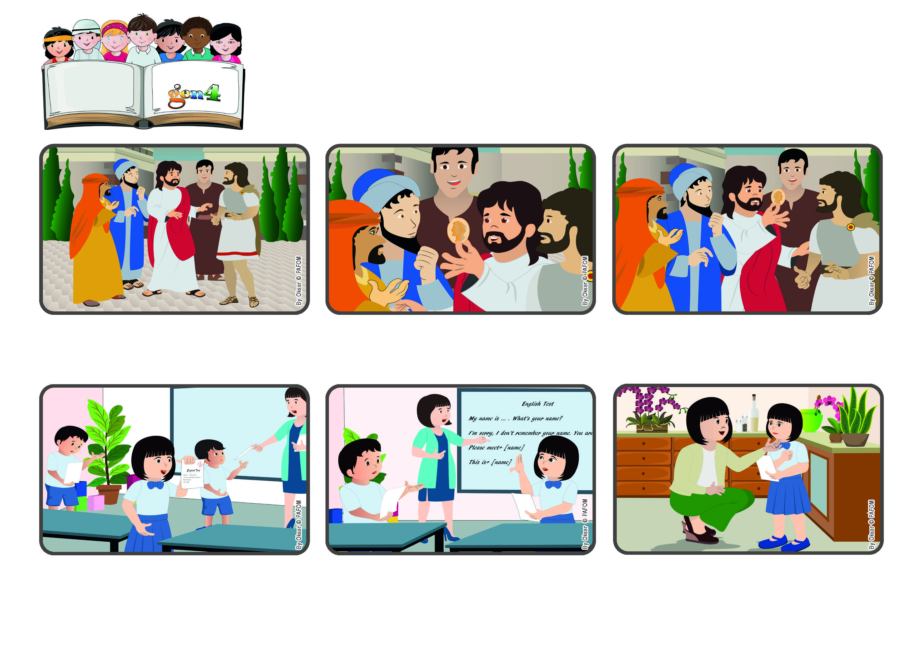

**October 2023**

**Word of Life**

**“Give therefore to the emperor the things that are the emperor’s,**

**and to God the things that are God’s” (Mt 22:21).**

(From the Liturgy of the Mass on the 29th Sunday of Ordinary Time)

**Let’s do everything well and carefully**

**So Jesus told them: “If this coin has Caesar’s picture on it, you can give it back to him. But be careful to also give to God what belongs to God!”**

**So these people asked Jesus if it was right to pay the taxes Caesar demanded. Jesus took one of the coins that was used to pay the taxes and asked them: “Whose picture is on this coin?” They said: “Caesar’s.”**

**Jesus was very wise. One day some people came up to him and started to ask him questions, trying to trick him. At that time there was an emperor whose name was Caesar. He was the one who made the laws and made people pay taxes for the needs of the empire.**

**A little Chinese girl whose name is May May told us: “I am six years old and today we had an English test in school. When the teacher gave me back my test, I saw that I got the highest grade possible. So I knew I would get a prize from her!**

**But then the teacher showed the whole class which were the correct answers to every question and I realized that I had made a mistake that she didn’t notice. I didn’t know what I should do. I wanted to tell the truth but I also wanted to have the prize.**

**But in the end I felt that I had to tell her, and so the teacher changed my grade. When my mother asked me why I had done that, I answered: “Because I want to love!” And she told me: “Good girl, May May! That must have been very hard to do!”**