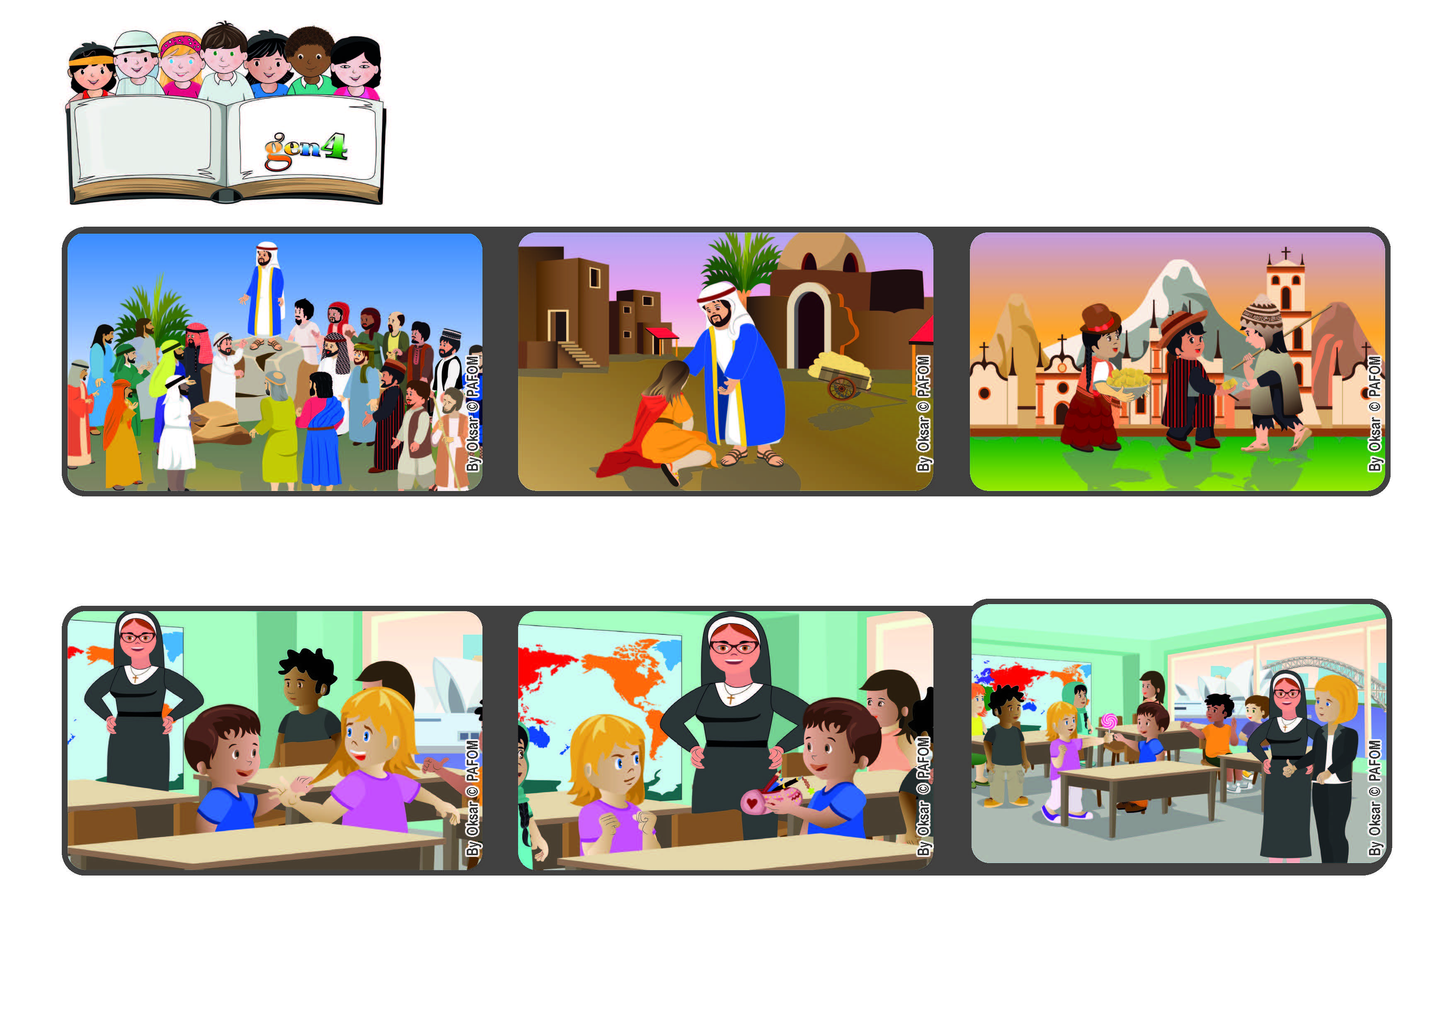

**Look at everyone with love**

**November 2022**

**Word of Life**

**“Blessed are the merciful, for they will receive mercy.” (Mt 5:7)**

**© PAFOM, Drawings and text provided by the Gen4 Center.**

**The Gen4 are the young children of the Focolare Movement, which was founded by Chiara Lubich.**

**The next day, Jazmin’s teacher, who is a Sister, told her mom: “You have a real angel in your house! So many times Jazmin helps me to start over again to love, because she is so patient with Lorenzo!”**

**By following his suggestions and in particular, being merciful to others, Jesus helps us to love God and other people in concrete ways, without expecting anything back from them.**

**Jesus explained to them that we cannot love God if we don’t love our neighbor. We have to do good to everyone, even to our enemies. To help us do this, he gave us some advice.**

**Jazmin from Australia shares her experience. “One day at school I had an experience of forgiving someone. I sit next to Lorenzo and he was always doing things to annoy me.**

**Once he even stole my pencil case! I really struggled with myself, because I was very mad at him, but then I remembered that Jesus asked us to love even our enemies and so I forgave him.”**

**After he had chosen the 12 apostles, Jesus came down from the mountain and stopped at a place where many people had gathered. They had come from many cities to hear him.**