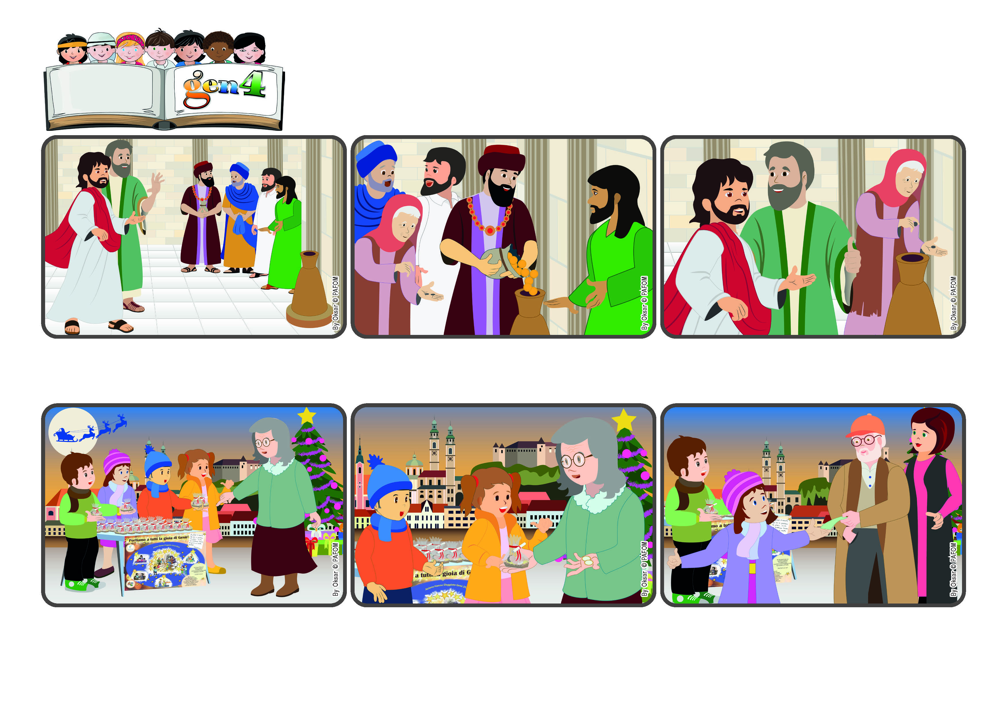

**Word**

**of Life**

(NOVEMBER 2024, from the liturgy of November 10, the 32nd Sunday in Ordinary Time)

**"She out of her poverty has put in everything she had, all she had to live on.” (Mk 12:44)**

**We always have something to give**

**Since we realized that she really didn’t have any other money, we gave it back to her. She had tears in her eyes as she thanked us. A little while later a man came by and gave us 10 Euros! Jesus is always very generous! (The Gen 4 from Slovenia)**

**As we always do, we told her she could have one without giving us anything. She was so surprised! She told us: “These days no one gives anything for free! You’re really special!” And she insisted on giving us the two Euros she had!**

**To remember the real meaning of Christmas, every year we Gen 4 make little statues of Baby Jesus and offer them to people on the street. It anyone gives a donation, we use it for people who are poor. Once a lady came up to our table. She wanted a Baby Jesus but she had very little money, just enough to buy something to eat.**

**He told the others: “This poor woman gave more than all the others! The rich ones only gave their extra money and instead she, who is so poor, gave all she had to live on.”**

**That was the place where people gave their offerings. Many people went in and those who were rich gave a lot of money. Instead a very poor woman, a widow, was also in line. Jesus noticed that she gave only two coins - which would be the same as a penny now!**

**Jesus was standing at the entrance to the temple of Jerusalem. He told the people listening to him not to be like those who just want to be admired by others, or who take the first place at banquets, or who like it when people bow to them in public.**

**© PAFOM, Drawings and text provided by the Gen4 Center.**

**The Gen4 are the young children of the Focolare Movement, which was founded by Chiara Lubich.**