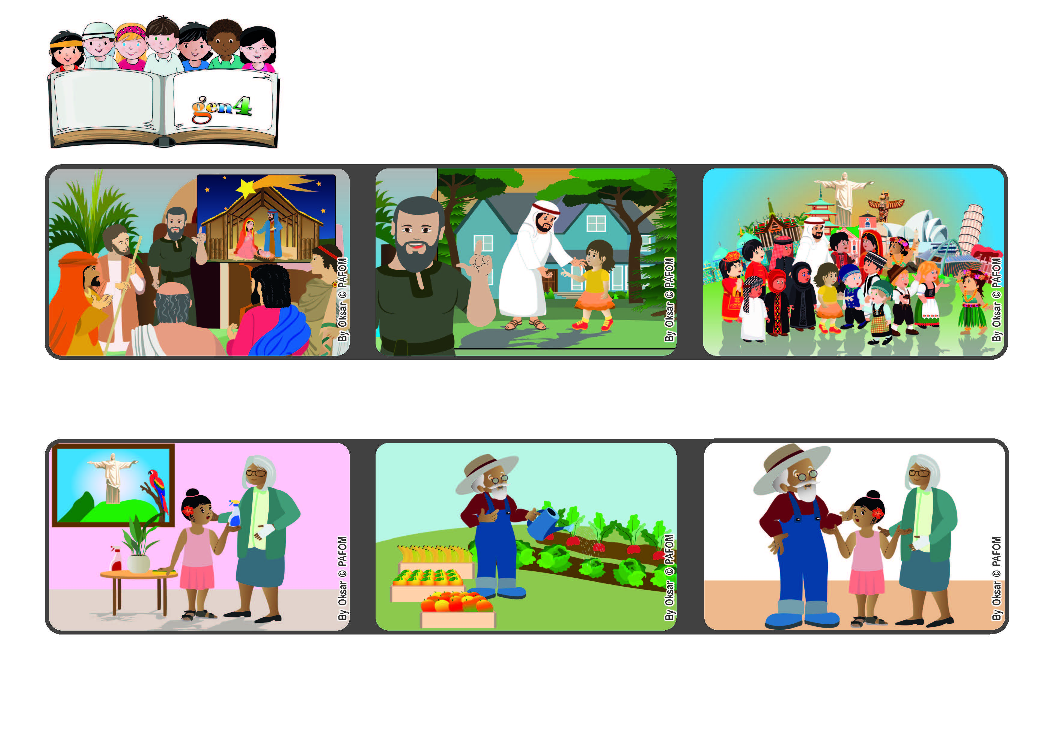
December 2022
Word
of Life
“Trust in the Lord forever,
for in the Lord God you have an everlasting rock.” (Is 26:4)
We are free to love everyone.
© PAFOM, Drawings and text provided by the Gen4 Center.
The Gen4 are the young children of the Focolare Movement, which was founded by Chiara Lubich.
My grandparents were very happy that I helped them and they thanked me a lot.” (Luisa from Brazil)
If we trust God we will have peace in our hearts and be free to love everyone. Then Jesus will live among us.
Isaiah reminded everyone that when things get hard for us, we should never stop trusting in God. He is always faithful, he never abandons us. He supports us like a strong rock.
“My grandmother’s hand really hurt her and so she couldn’t do anything. I went to her house and helped her to clean, wash the dishes and tidy up everything.
My grandfather couldn’t help because he had to water the plants in the field and also collect all the fruit to be sold.
Prophets are people who tell peple how much God loves them. One of these was a man named Isaiah.

