**“Trust in the Lord forever,**

**for in the Lord God you have an everlasting rock.” (Is 26:4)**

**We are free to love everyone.**

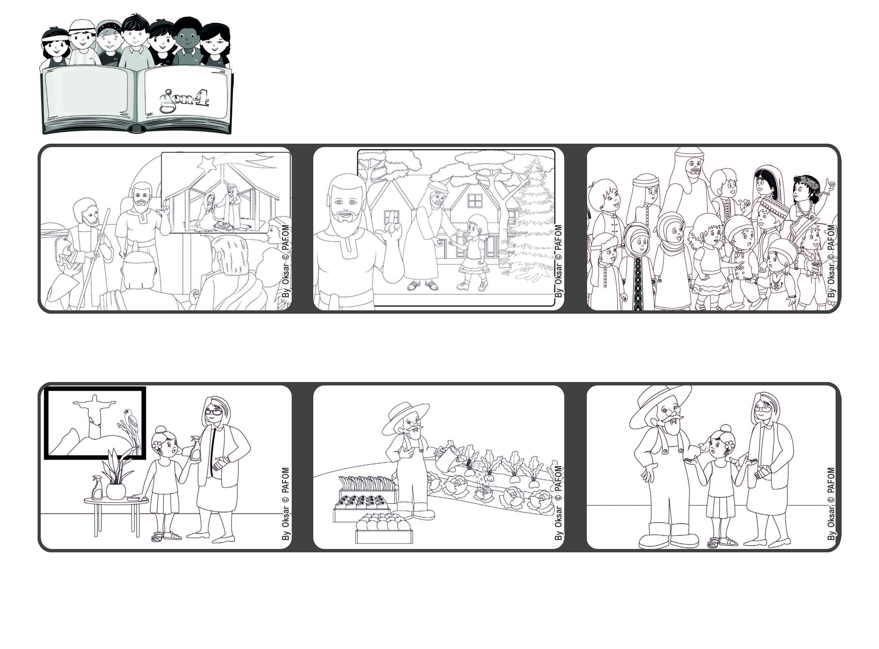

**December 2022**

**Word of Life**



**© PAFOM, Drawings and text provided by the Gen4 Center.**

**The Gen4 are the young children of the Focolare Movement, which was founded by Chiara Lubich.**

**My grandparents were very happy that I helped them and they thanked me a lot.” (Luisa from Brazil)**

**If we trust God we will have peace in our hearts and be free to love everyone. Then Jesus will live among us.**

**Isaiah reminded everyone that when things get hard for us, we should never stop trusting in God. He is always faithful, he never abandons us. He supports us like a strong rock.**

**“My grandmother’s hand really hurt her and so she couldn’t do anything. I went to her house and helped her to clean, wash the dishes and tidy up everything.**

**My grandfather couldn’t help because he had to water the plants in the field and also collect all the fruit to be sold.**

**Prophets are people who tell peple how much God loves them. One of these was a man named Isaiah.**