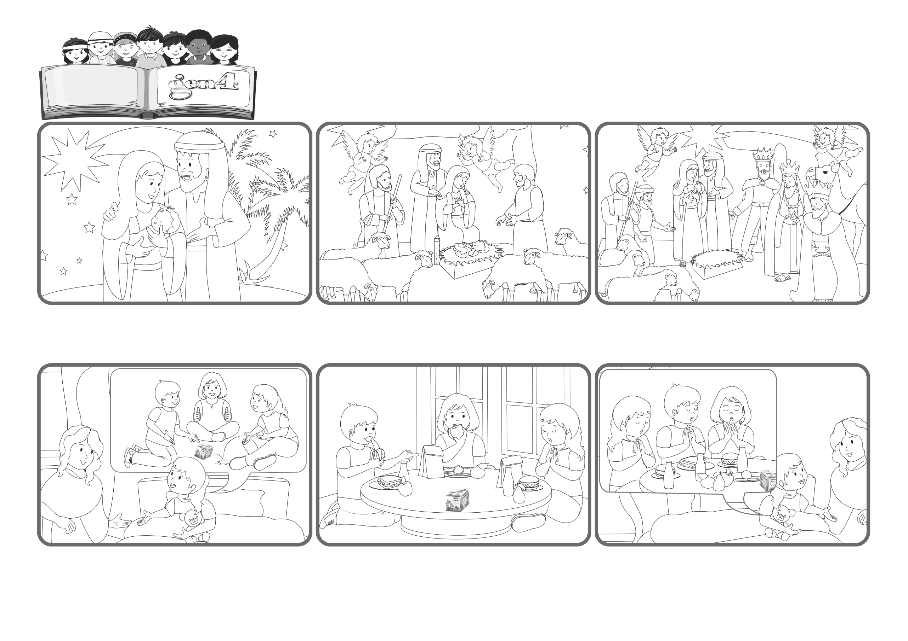

« All the ends of the earth shall see the salvation of our God » (Is 52:10).
Jesus was born for all people on earth
Word
of Life
(From the liturgy of December 25, Christmas Day)
The next day, Eleonora said: “Mommy, guess what happened today? Before eating my lunch, I folded my hands and said: ‘Jesus I thank you for this good lunch’! The other children looked at me and then they did the same!”
But one day when she came home, Eleonora told her mom: “Mommy, when we start to eat, my classmates never say a prayer. Instead I feel that Jesus in my heart is telling me to say grace.”
Eleonora goes to kindergarten. She likes school very much and has many friends. She plays with everyone. She always has a lot to tell her mom and when she goes to bed, she thanks God for a wonderful day.
And from countries far away, some wise people arrived with magnificent gifts to honor him. Yes, Jesus came among us to bring God’s salvation and the life of heaven to every person on earth!
Mary and Joseph were there looking at him with great love! The shepherds from nearby came silently and fearfully to see this child who was so special that the angels announced his arrival with songs!
What joy there is in a family when a new baby is born! All the relatives and friends come around to celebrate this new child. And yet who came to that stable on a cold night to celebrate the birth of a baby laying on some straw instead of in a cradle?
© PAFOM, Drawings and text provided by the Gen4 Center.
The Gen4 are the young children of the Focolare Movement, which was founded by Chiara Lubich.

