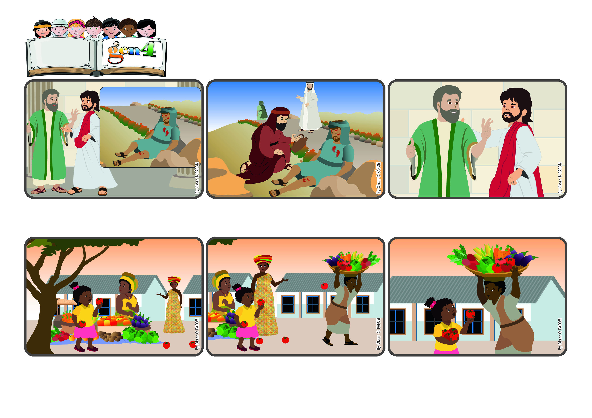

**“You shall love the Lord your God (...) and your neighbor as yourself.” (Lk 10:27)**

(January 2024, Theme for the 2024 Week of Prayer for Christian Unity)

**Word**

**of Life**

**Let’s love God and everyone around us**

**A priest passed by that way and also a leader of the synagogue. They looked at him but did not help him. It was only a foreigner, a Samaritan, who stopped, put bandages on his wounds and then took him to a nearby hotel. He paid the man there to take care of him.**

**A person who had studied a lot asked Jesus: “What is the most important thing to do in life?” Jesus answered with a story: There was a man on a journey and he was attacked by robbers, who stole evereything he had and left him half dead by the side of the road.**

**“Who do you think did the most important thing?” Jesus asked the man. He answered: “The third one who took care of him because he was wounded.” “That’s right!” Jesus said, “Now you go and do the same for every neighbor you meet.”**

**Maya said: One day I was going home and I passed by the market where there are always many people selling fruit and vegetables. When I said hello to one lady, I saw on the ground in front of me a tomato, and then another and then still another....**

**The man looked very tired and worried. And so I stopped and picked up all the tomatoes. He thanked me with a big smile and I was happy too because I had been able to help him. Maya from Uganda**

**I looked around and saw that they came from a big basket that a man was struggling to carry because it was so heavy! No one had noticed that he was losing all those beautiful tomatoes that would soon be crushed under people’s feet!**

**© PAFOM, Drawings and text provided by the Gen4 Center.**

**The Gen4 are the young children of the Focolare Movement, which was founded by Chiara Lubich.**