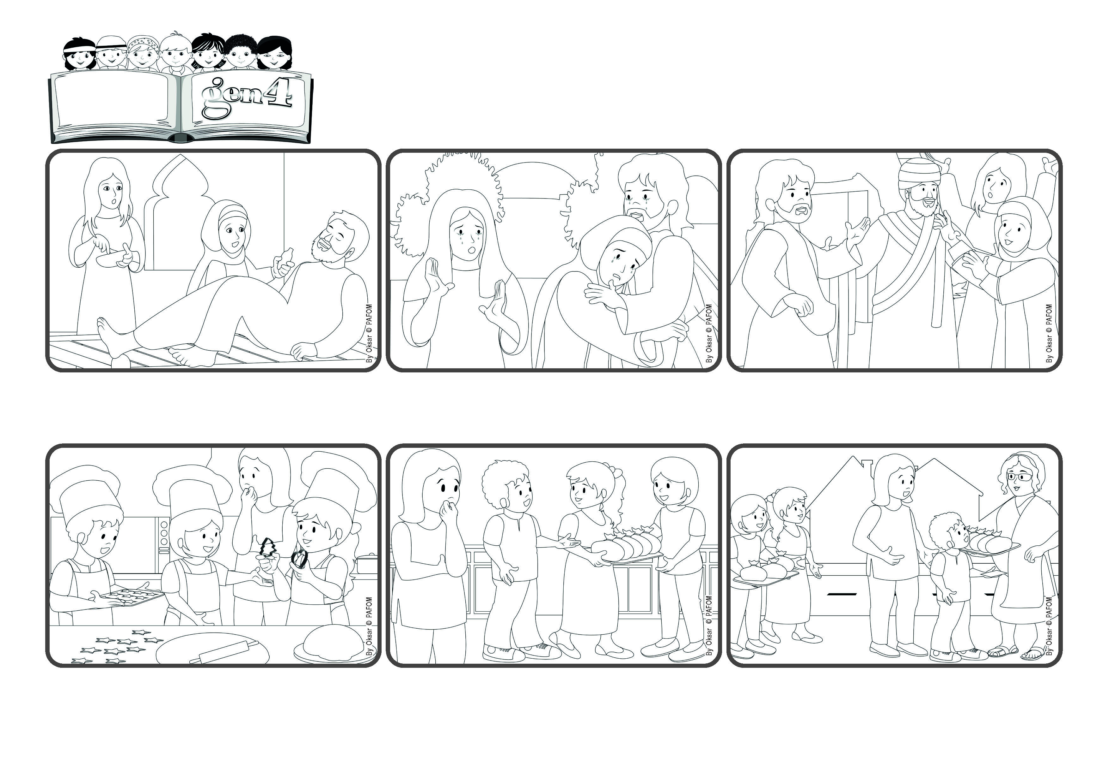

**“Do you believe this?” (John 11:26)**

(January 2025 – Theme for the Week of Prayer for Christian Unity)

**I believe in you, Jesus !**

**Word**

**of Life**



**Pedro, Maria and Teresa live in Paraguay and they made cookies to sell to help the poor people. Cecilia heard about it and wanted to help, but she thought: “Nobody here has money to buy cookies!”**

**As soon as they left the house, a neighbor stopped them and asked what they were doing – and she bought the whole tray of cookies! They were so happy and went back inside to get the cookies that didn’t look so nice, but they sold all of them, too! Jesus really works miracles if we believe in him!**

**© PAFOM, Drawings and text provided by the Gen4 Center.**

**The Gen4 are the young children of the Focolare Movement, which was founded by Chiara Lubich.**

**The cookies were ready, so they said, “Let’s go and sell them!” Cecilia was worried and thought: “At this time of the day, there won’t be anyone on the streets! But Jesus will help them because they have such great faith!” And she went with them.**

**Jesus came on eath to bring us the life that will never end. He asked Martha, “Do you believe this?” She said, “Yes, I believe.” Then he told them: “Open up the tomb. Let him come out!” And Lazarus came out. Jesus is truly the Son of God who gives life.**

**His two sisters said: “Let’s tell Jesus! He’ll come and make him well again!” But by the time Jesus got there, Lazarus was already dead and had been buried. Jesus cried over the loss of his friend, but Martha told him: “If you had been here, he would not have died!”**

**Jesus knew many people and had many friends, like Martha and Mary and their brother Lazarus who lived in Bethany. One day, while Jesus was visiting another town, Lazarus got very sick.**