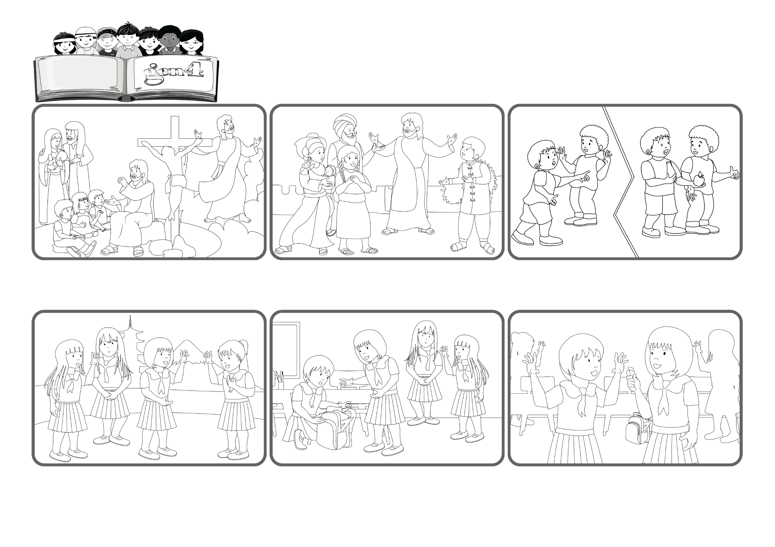

Word
of Life
“There is one body and one Spirit,
just as you were called to the one hope of your calling.” (Eph 4:4)
From the theme for the 2026 Week of Prayer for Christian Unity
We are all brothers and sisters
My name is Rin and I’m from Japan. This year I have a lot of new classmates. It’s hard to be a friend to all of them but I try. For example, I kept loving one girl who never even answered me when I said Hello. Instead now she responds to my greetings.
We can live like that today too! Let’s not think of ourselves and instead do good to others, always forgiving each other as he did with us.
Jesus came on earth to teach us to live as one big family. It doesn’t matter that we are different from one another because we love one another and help each other. God is the Father of everyone and makes us all brothers and sisters!
We just celebrated Christmas, the day that Jesus, the Son of God, came on earth for us. In the next few months, we will remember other important moments of his life, like what he did and taught us, right up to his death and resurrection and return to his Father.
One day one of my classmates lost her eraser. She looked everywhere but couldn’t find it. I saw that she was really sad and that no one was helping her. Right away I went over and started looking with her, but we still couldn’t find it!
That erasure had really disappeared! Finally, our other classmates started to look too and they found it! It was so nice, not only because we found the eraser but because the whole class came together to make her happy!
© PAFOM, Drawings and text provided by the Gen4 Center.
The Gen4 are the young children of the Focolare Movement, which was founded by Chiara Lubich.

