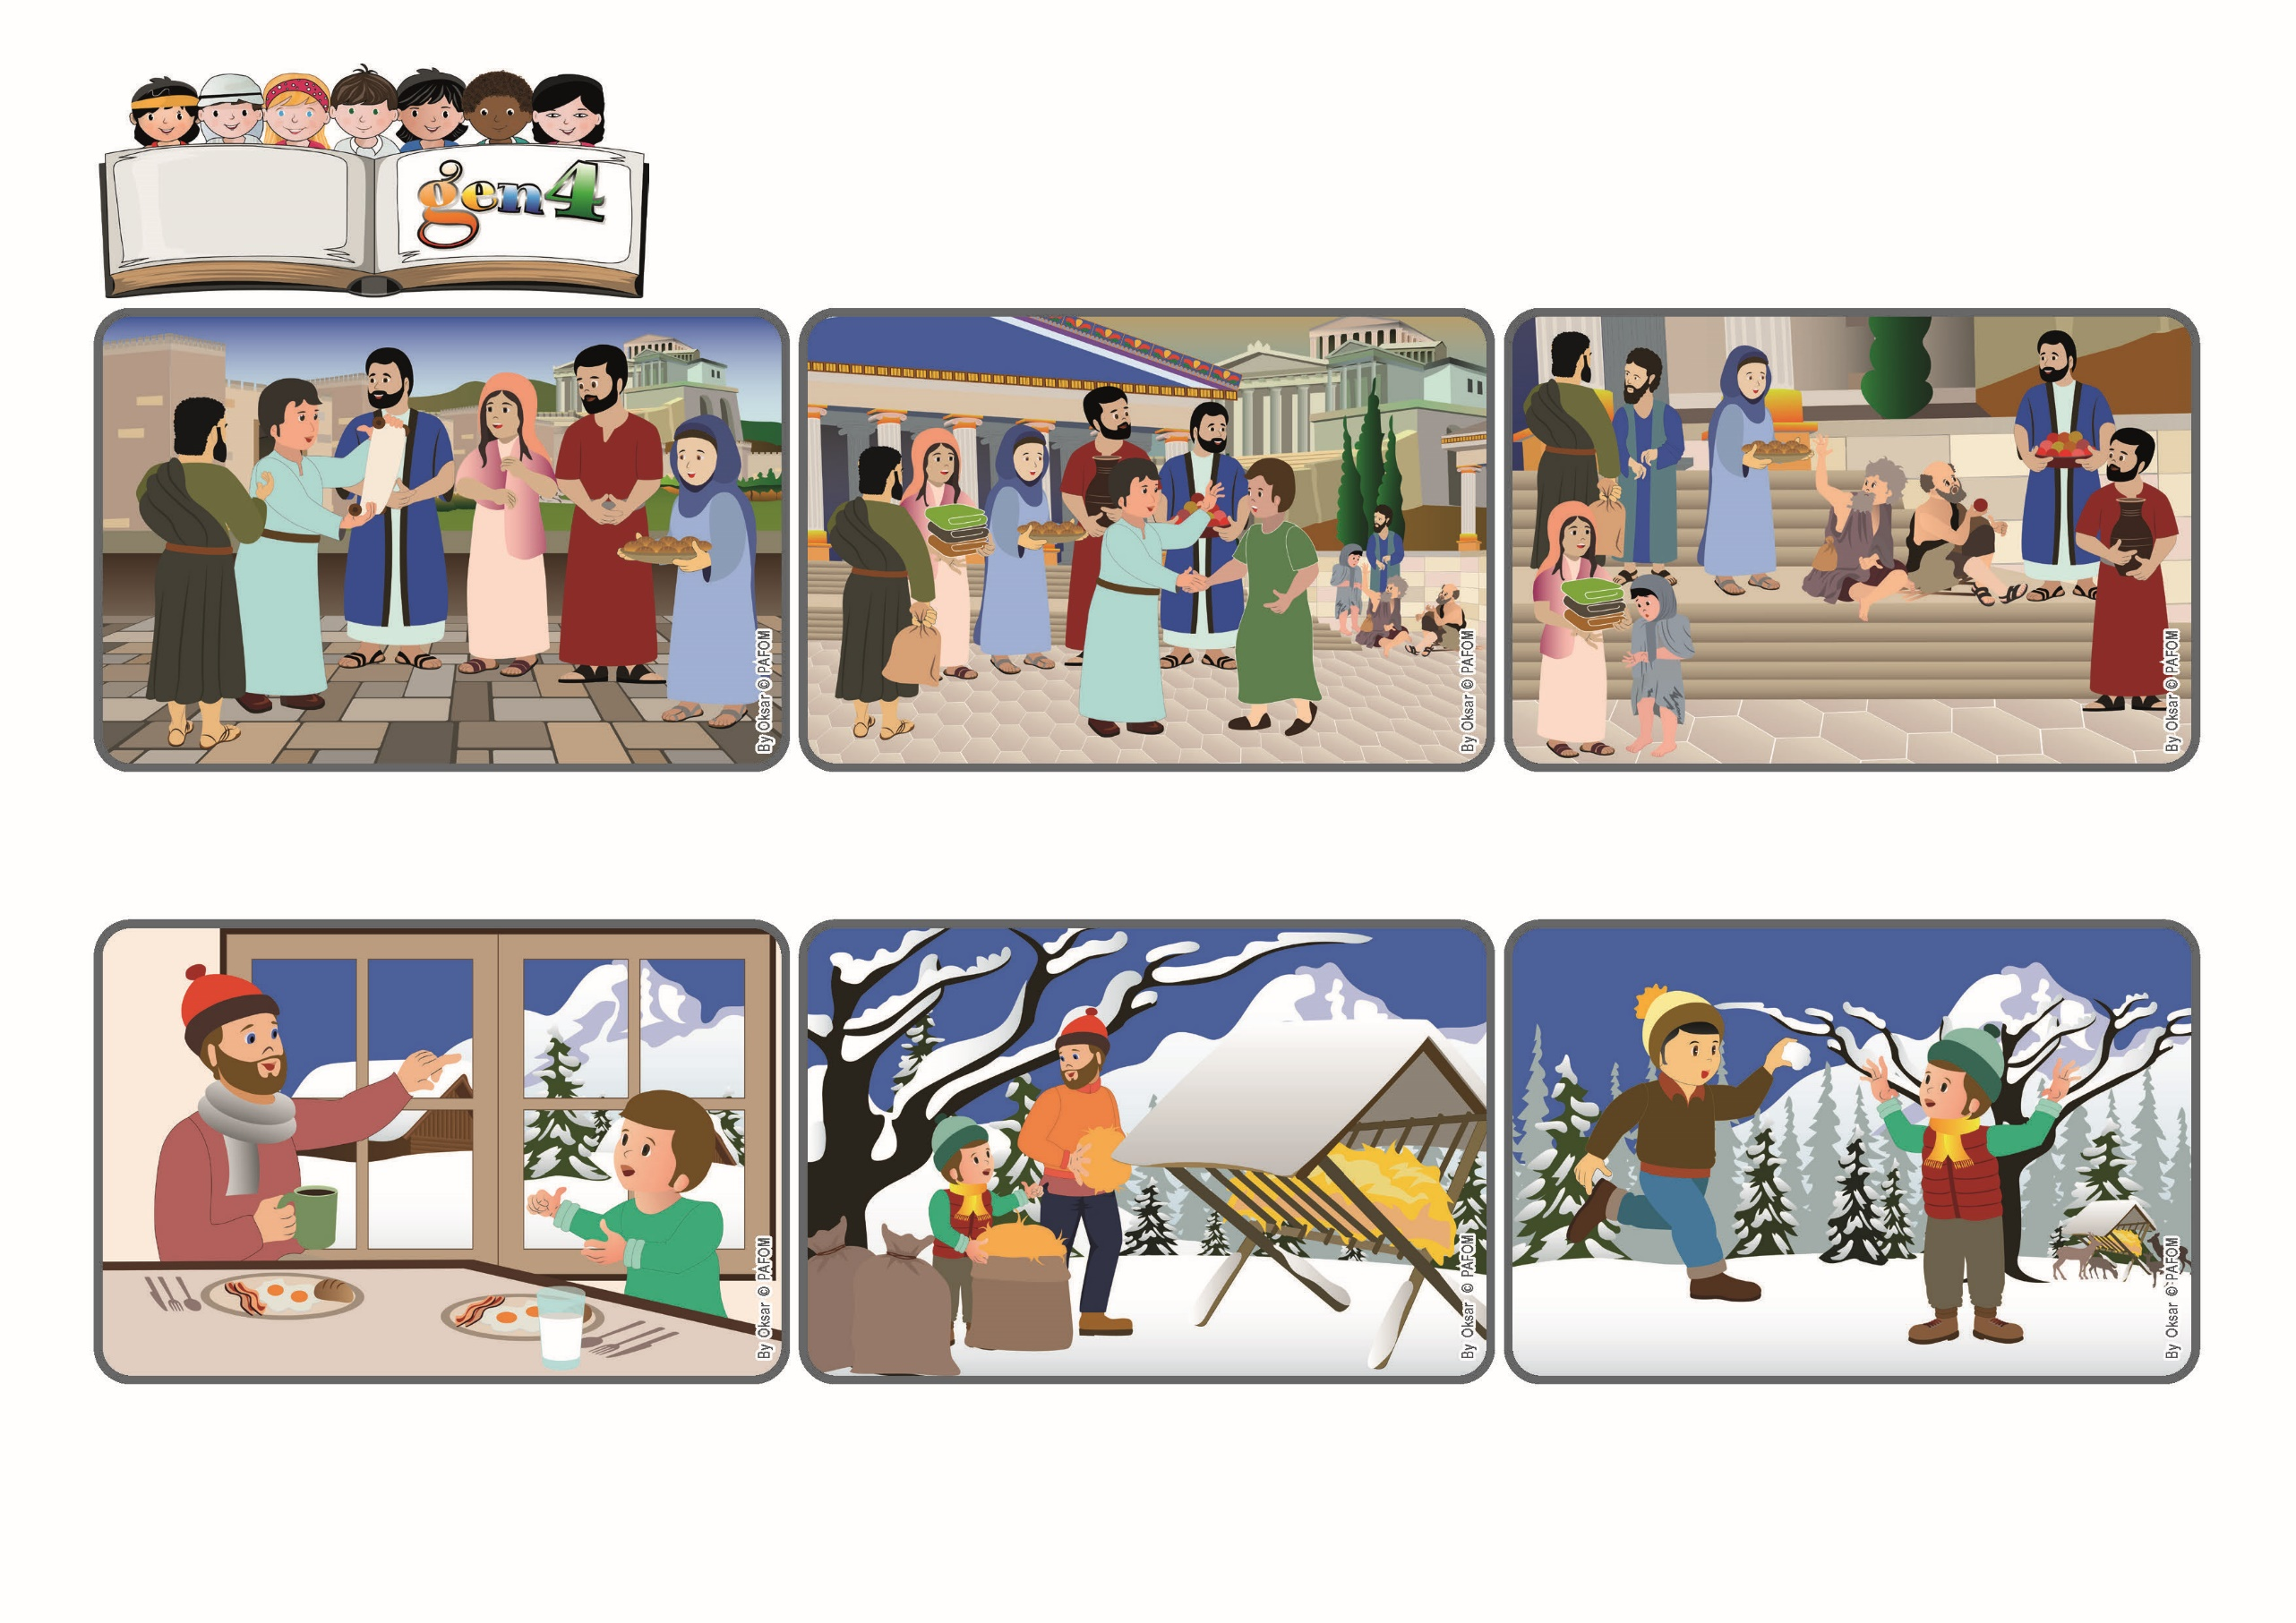

(**February 2024**, Bible verse chosen by the Lutheran Churches for the year 2024)

**“Let all that you do be done in love.” (1Cor 16:14)**

**Word**

**of Life**

**Let’s do everything with love!**

**It was still very early in the morning and Janez felt sleepy. He wanted to stay in the warm house, but then he thought: “Maybe dad needs help!” So he got dressed and went with him. When they got to the first place, he put a lot of love into keeping the bag open so that his dad could get the hay out.**

**When they got close to the next place, they met Martin, a Gen 4 friend of Janez. He asked: “Can I help, too?” Working together was even better! They finished in no time...and they also had a lot of fun throwing snowballs at one another!**

**Janez lives in a little town in Slovenia. One Sunday during the winter his father told him: “It’s cold out but it will be a beautiful day! Do you want to come with me to the woods? I have to go and put hay in the cribs for the deer to eat.”**

**After the resurrection, Christians began to form groups in various cities. The apostles travelled around to visit them and help them to live what Jesus had taught them. That’s why Paul wrote this message to the Christians living in Corinth.**

**He tells them to have a lot of love for those who are in need and to try to save some money to help them. He also asked them to welcome with joy all the friends of Jesus who came to announce his words to them.**

**Then he reminds them to always be attentive to doing everything with love. This is how he ends his letter: “Let all that you do be done with love!” Yes, because it is love that identifies us as friends of Jesus!**

**© PAFOM, Drawings and text provided by the Gen4 Center.**

**The Gen4 are the young children of the Focolare Movement, which was founded by Chiara Lubich.**