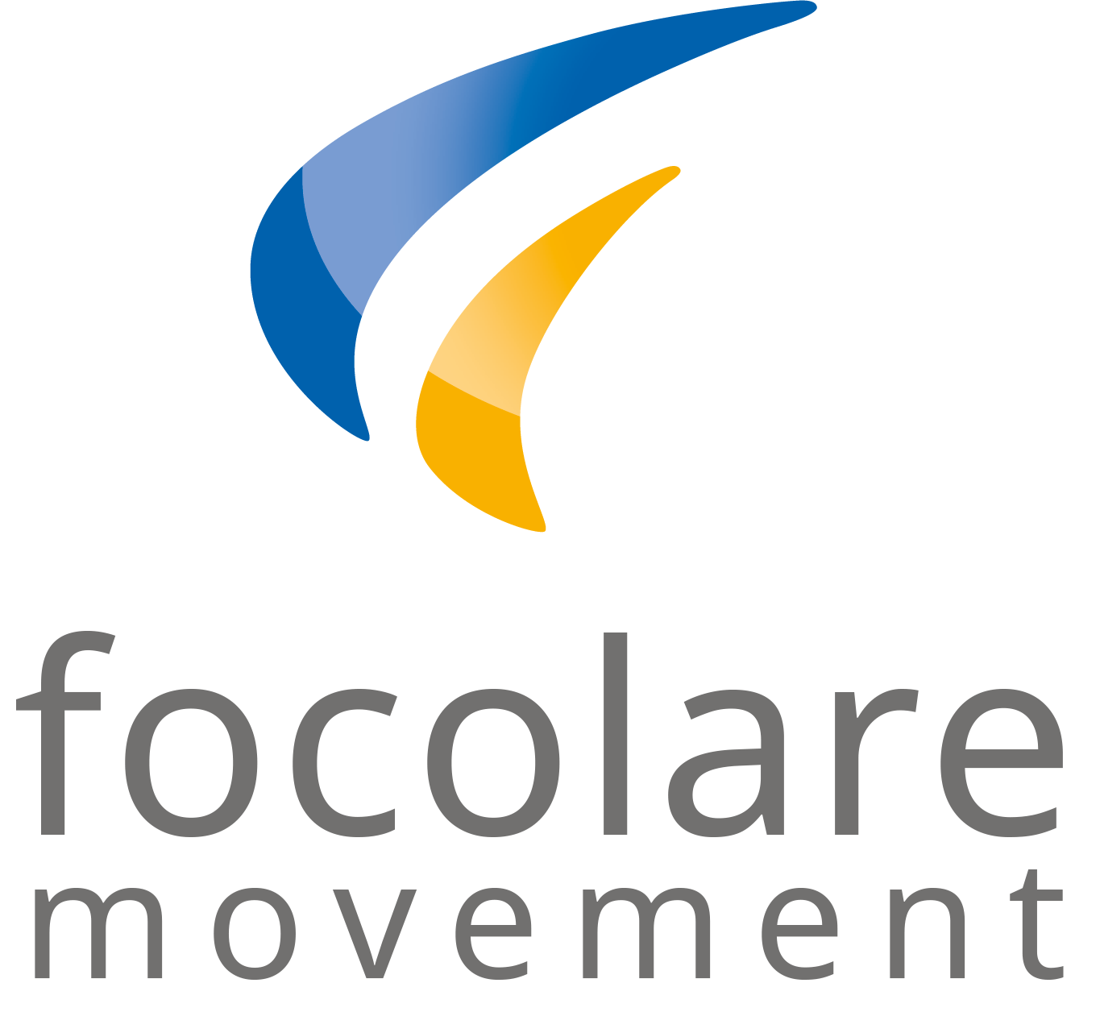

**Word of Life**

**March 2021**

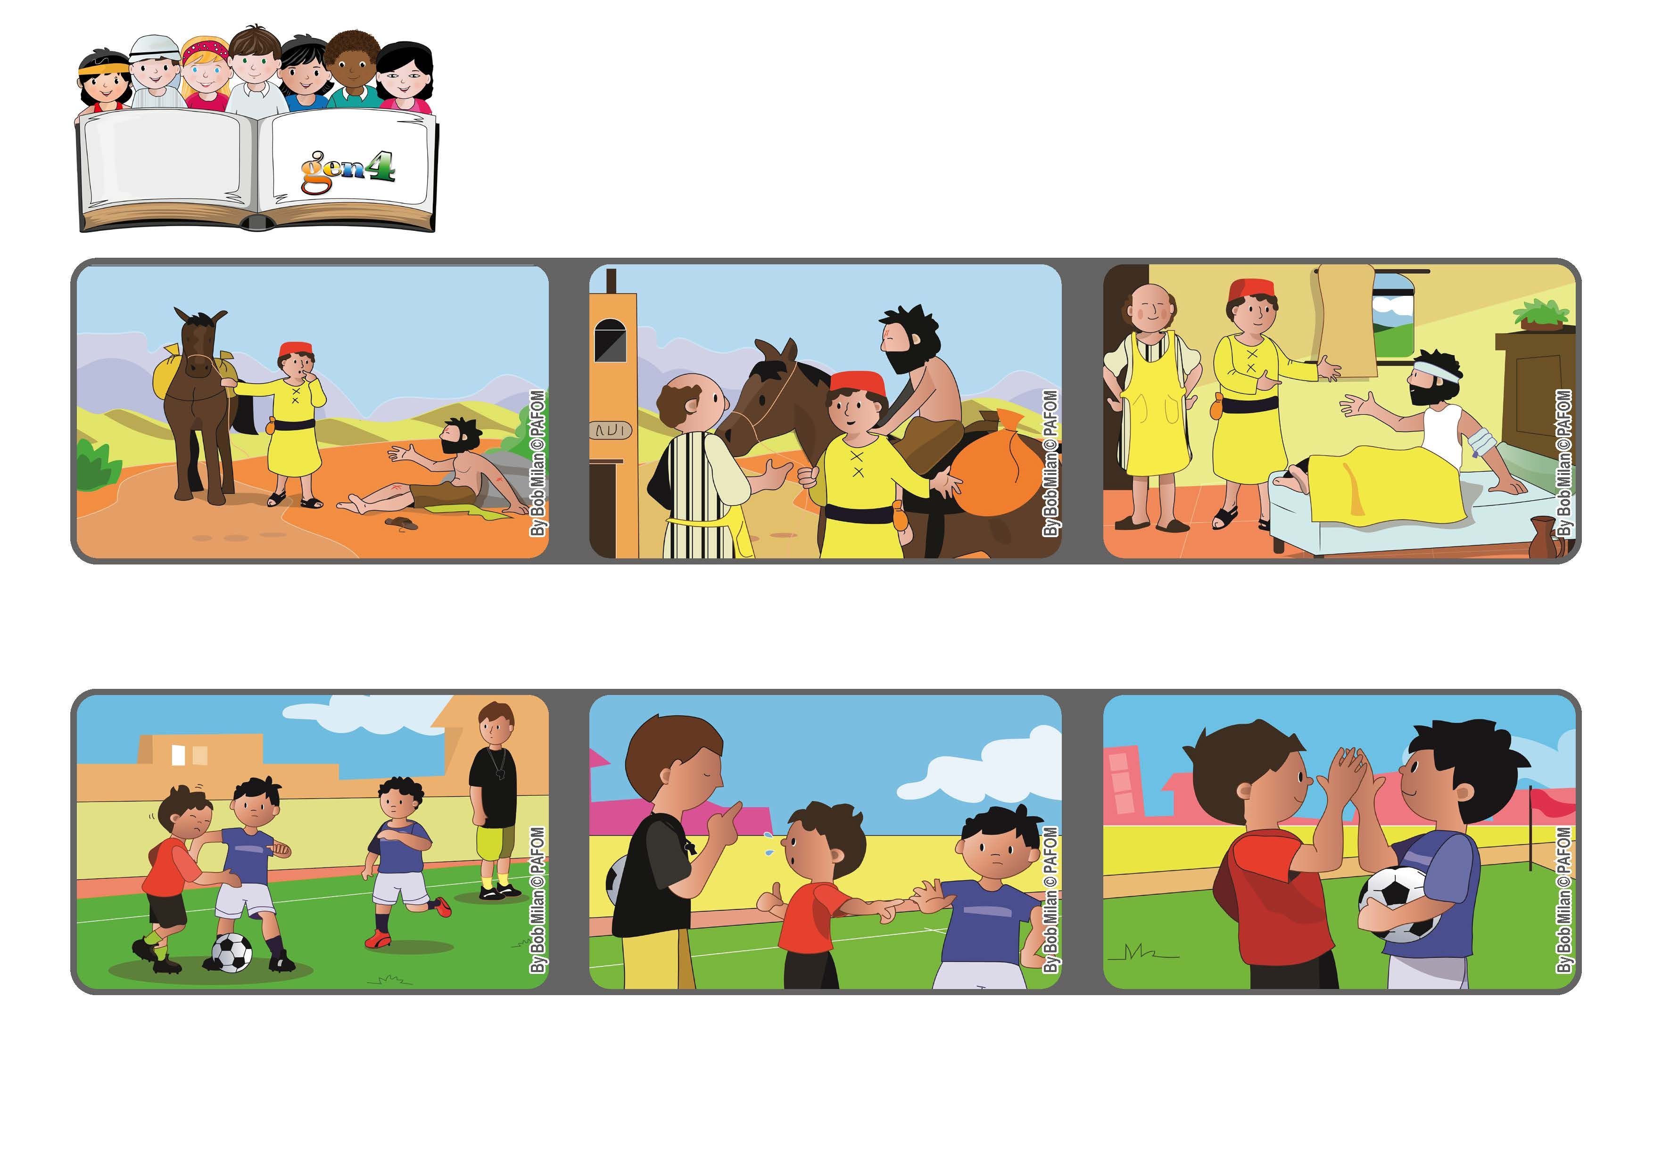

**“Make me know your ways, O Lord, teach me your paths.” (Ps 25:4)**

**Point your compass on love**

**Pope Francis wrote a very beautiful letter to remind us that we are all brothers and sisters and so it’s possible for us to love one another as Jesus taught us.**

**Robert from France: One day during a soccer game, my team was winning. The other team started to elbow me until I fell down and bruised my chest.**

**Helping someone in trouble or doing something for others, like the Good Samaritan, is always the best choice.**

**Sometimes we are undecided and don’t know what is the right thing to do.**

**I was crying and called for a foul, but it wasn’t accepted. I got very angry and decided that I would start to elbow the boy who made me fall down.**

**But then I thought about Jesus in him and I made a different decision. I forgave him. At the end of the game, we were still friends.**

**© PAFOM, Drawings and text provided by the Gen4 Center.**

**The Gen4 are the young children of the Focolare Movement, which was founded by Chiara Lubich.**