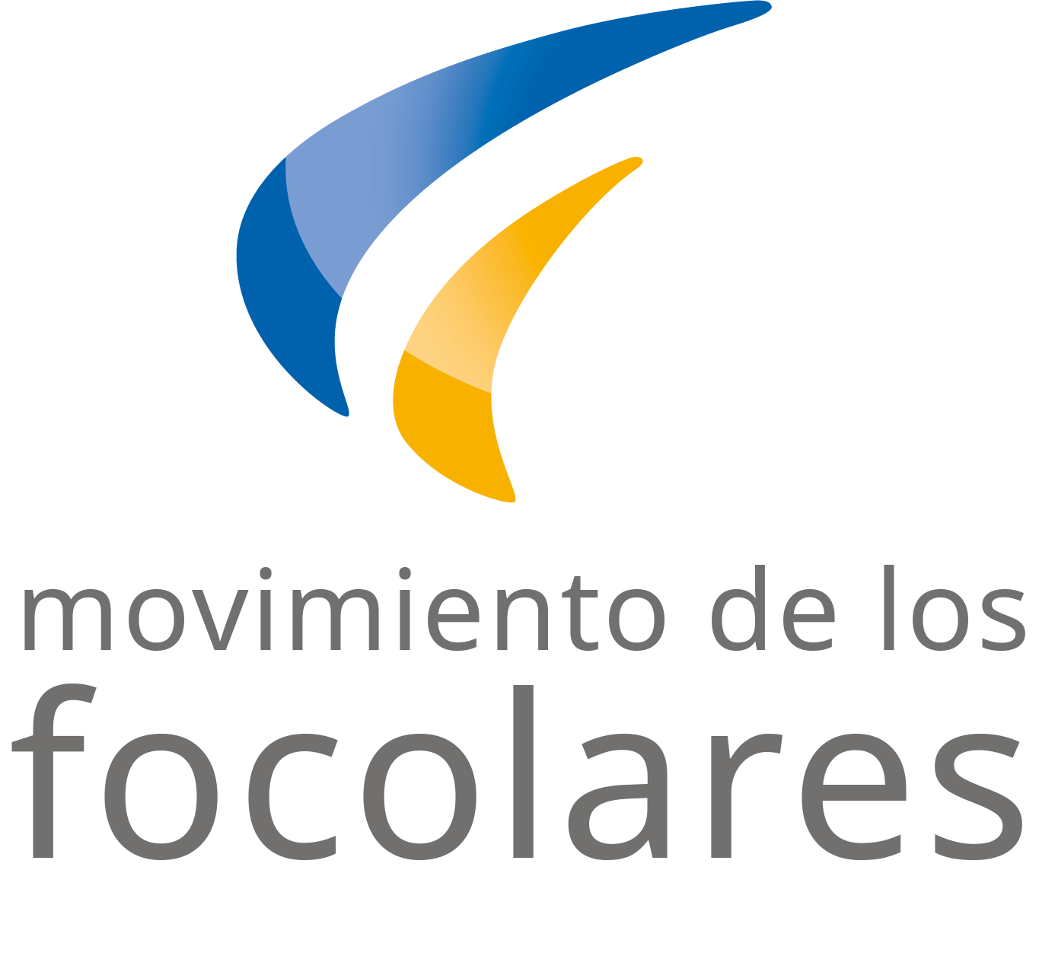

**March 2022**

**Word of Life**

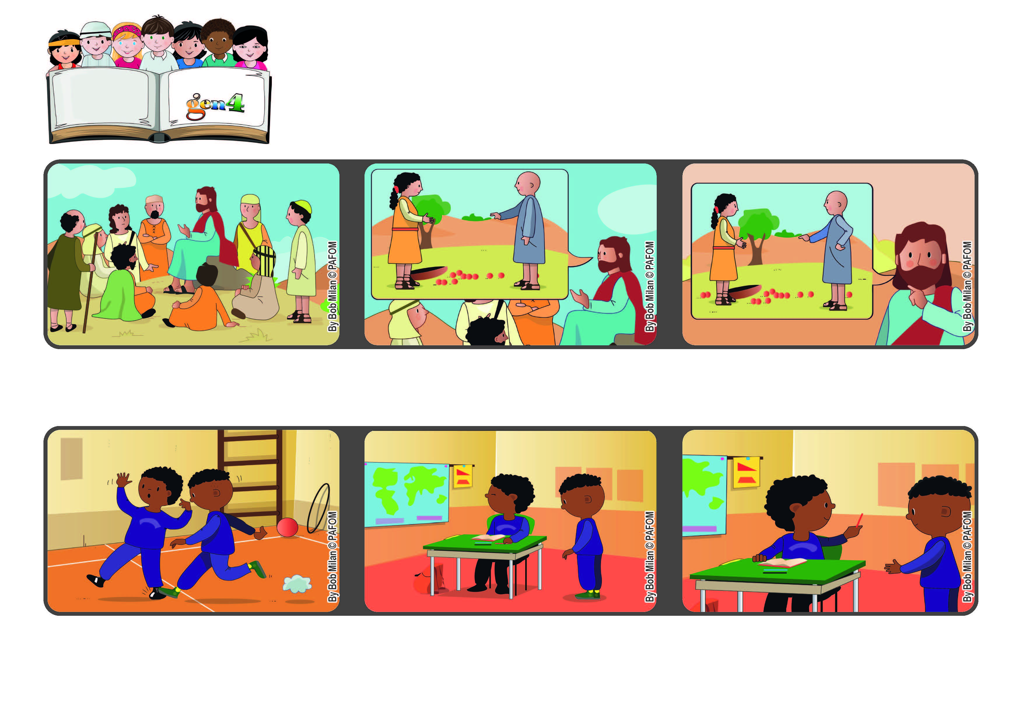

**“Forgive us our debts, as we also have forgiven our debtors” (Mt 6:12).**

**Let’s forgive others!**

**When we went back into the classroom, he asked me for a pencil, but I was still mad at him.**

**God always forgives everyone and so we should do the same.**

**In that prayer we ask God to forgive us for all the bad things we did and we promise to forgive anyone who hurt us.**

**Jesus went up on a hill and told the people that they should call God their Father. Then he taught them the “Our Father.”**

**Then I remembered that I should forgive him and so I gave him the pencil. Experience of Pierre from the Ivory Coast**

**One day in the gym one of my classmates hurt my foot and I got very mad at him.**

**© PAFOM, Drawings and text provided by the Gen4 Center.**

**The Gen4 are the young children of the Focolare Movement, which was founded by Chiara Lubich.**