

**April 2020**

**Word of Life**

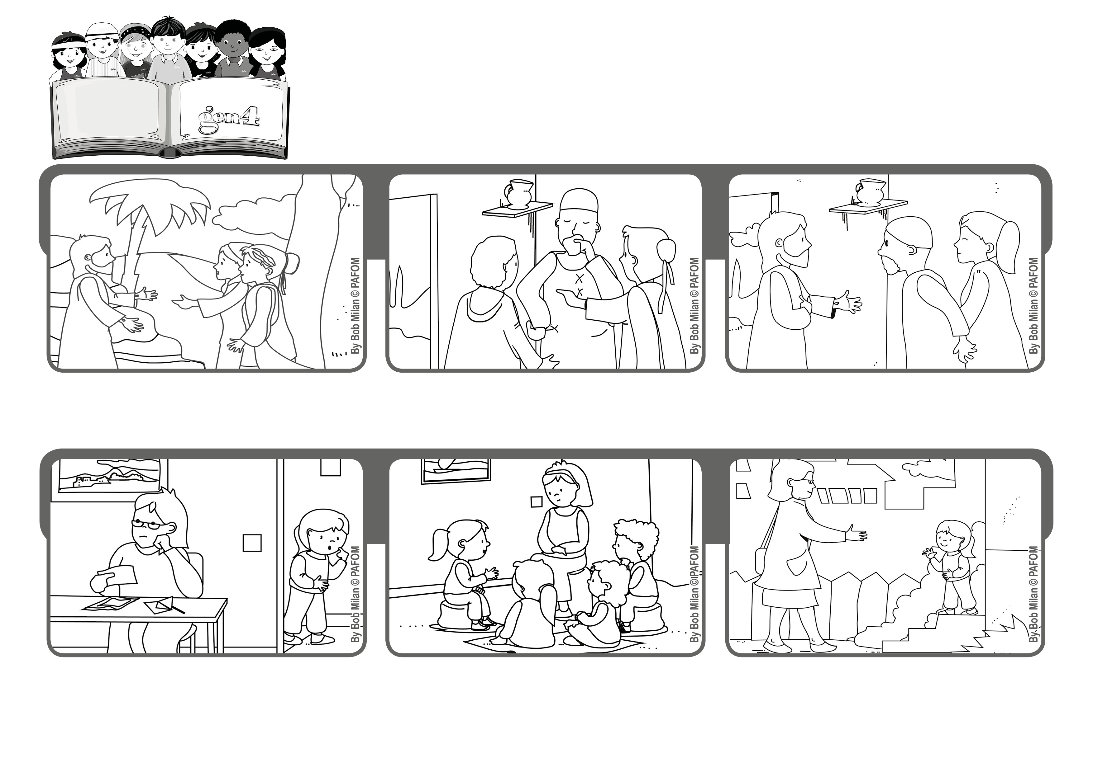

**“Blessed are those who have not seen and yet believe” (Jn 20:29).**

**“I believe!”**

**Isabel lives in Bolivia and her mom was very worried because she had lost her job and now they didn’t have enough money to live on!**

**At every Gen meeting, Isabel and the other Gen 4 asked Jesus for help. They were sure that he would hear their prayer.**

**And he did! Isabel told her mom: “Do you know why you found a job? Because we asked Jesus for it!”**

**Jesus rose from the dead, just as he had promised! He appeared to some women and then to his apostles and other followers.**

**Thomas was one of the twelve apostles but he wasn’t there when Jesus came. He said he wanted to see and touch him before he would believe.**

**© PAFOM, Drawings and text provided by the Gen4 Center.**

**The Gen4 are the young children of the Focolare Movement, which was founded by Chiara Lubich.**

**One day the apostles were all together and Jesus appeared to them again. Thomas realized the Jesus was really alive. He had risen from the dead!**