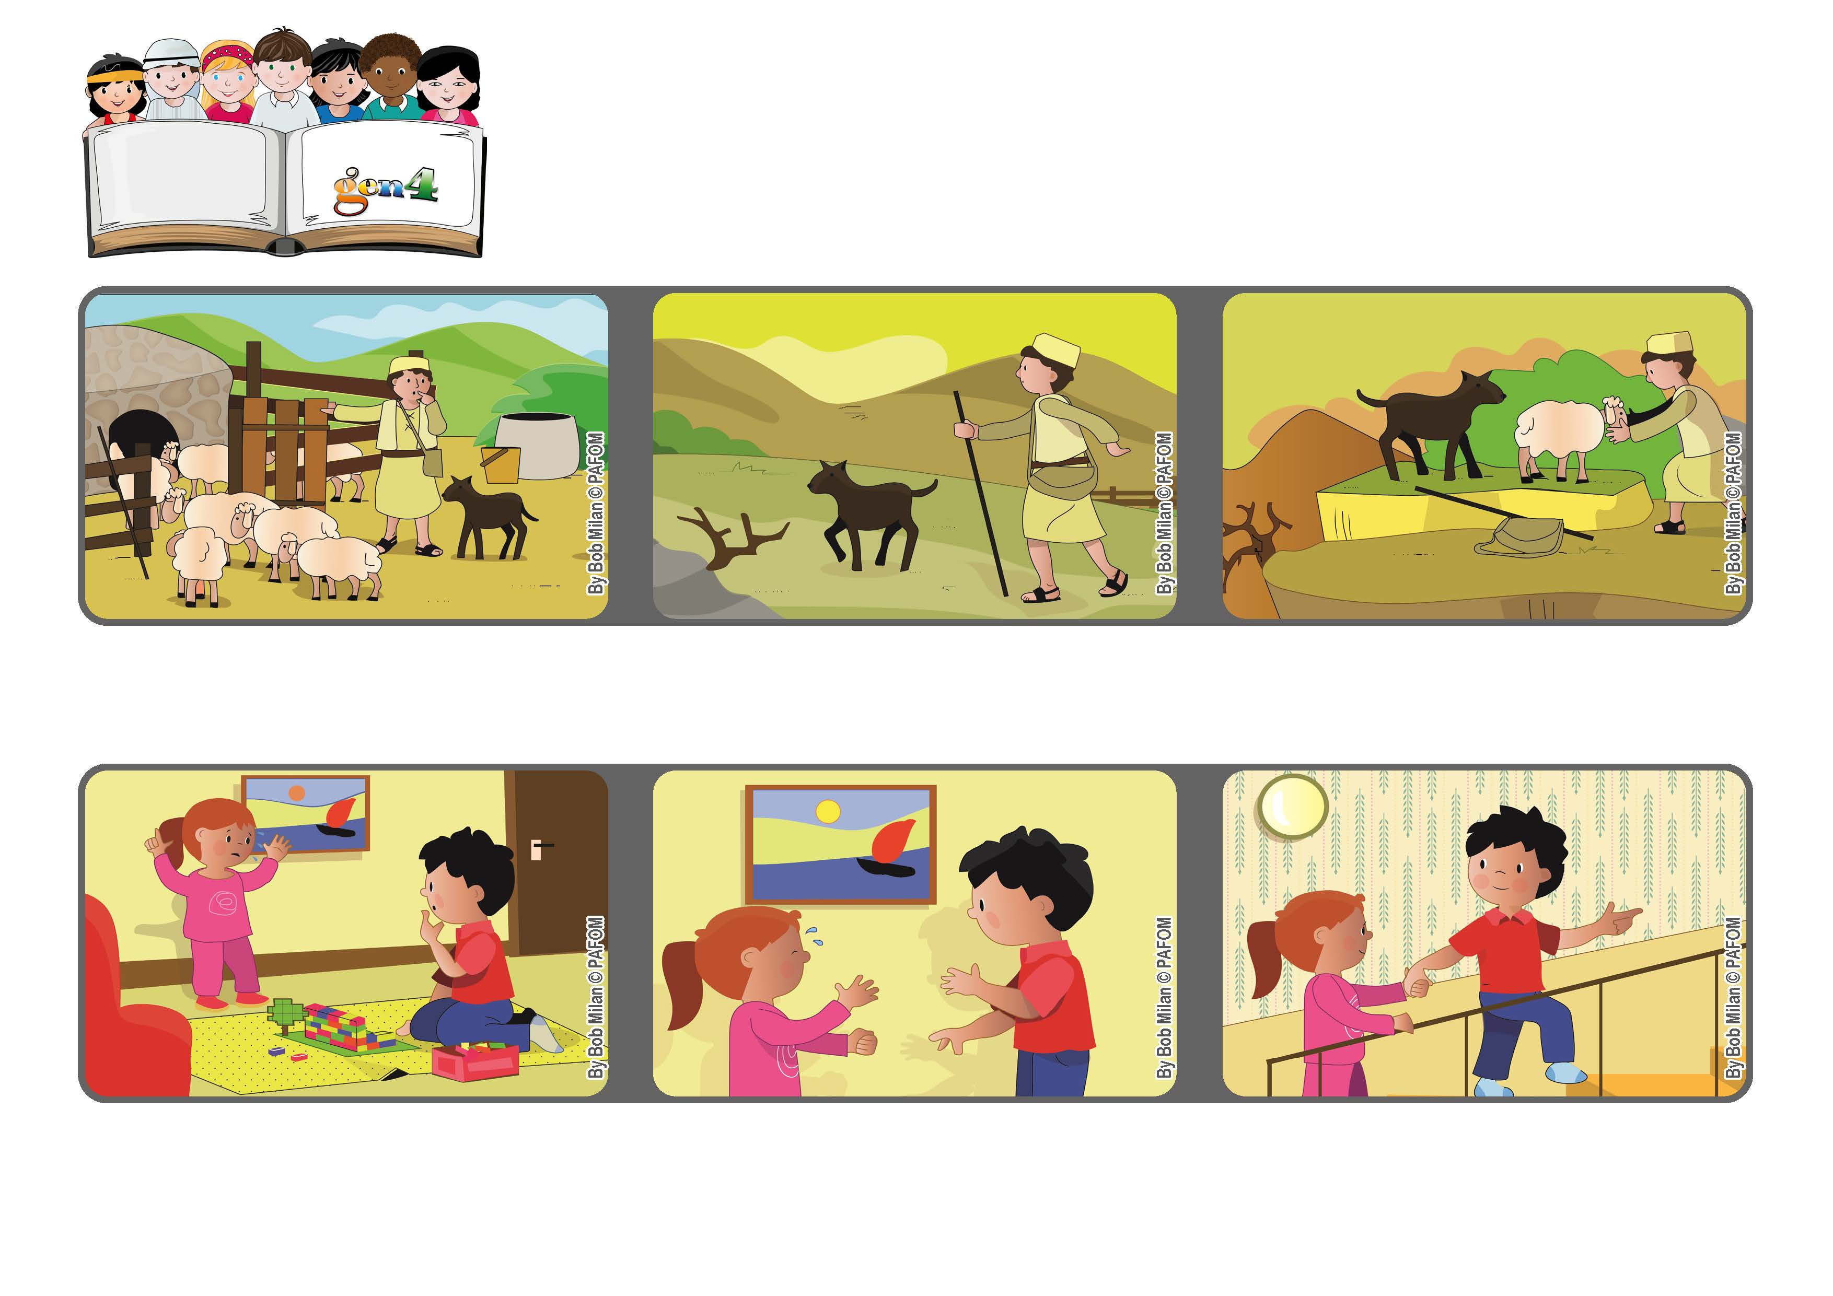
April 2021
Word
of Life
“I am the good shepherd.
The good shepherd lays down his life for the sheep” (Jn 10:11).
Take care of the weakest ones
Jesus is like a good shepherd who knows his sheep and takes care of them.
When he got home, he realized that one lamb was missing and so he ran back to find it.
Even though he was tired from working all day, he looked and looked until he found it.
She said she wanted our mother, but she was on the second floor and couldn’t hear her crying.
One day I was at home, playing with my construction kit. My little sister started crying.
So I tried to make her feel better. I look her hand and helped her go up the stairs to where our mother was working. (Bob – Canada)
© PAFOM, Drawings and text provided by the Gen4 Center.
The Gen4 are the young children of the Focolare Movement, which was founded by Chiara Lubich.

