**Word of Life**

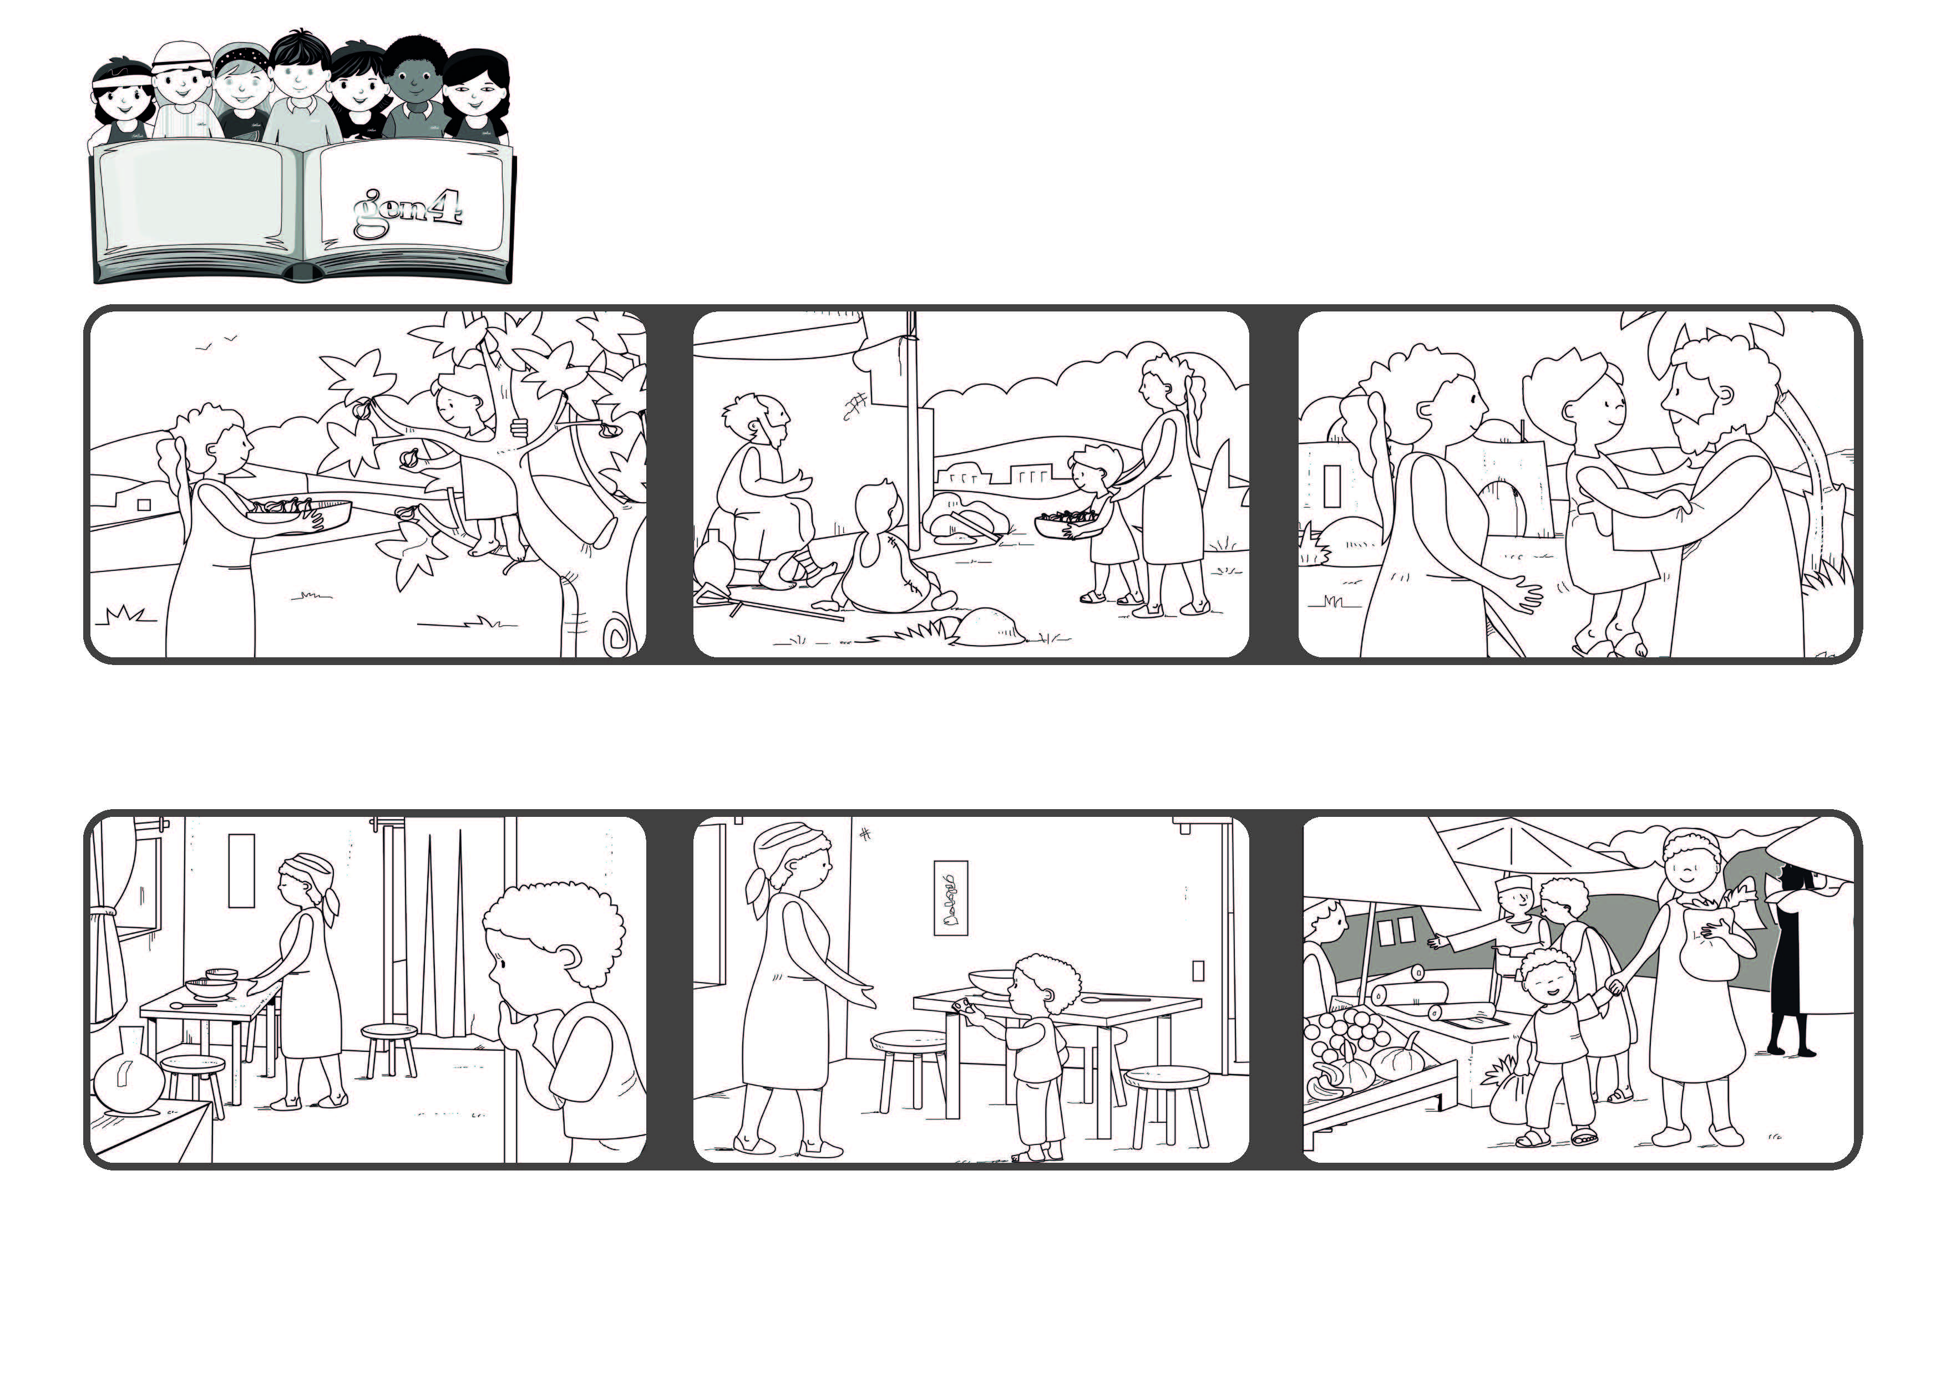

**May 2021**



**“God is love and those who abide in love abide in God,**

**and God abides in them” (1Jn 4:16)**

**Never stop loving**

**The first Christians loved one another and helped anyone in need.**

**They shared all their things with those who were poor.**

**Because of their love, God was in their hearts and in their midst.**

**Elisabeth ran and got her coins and gave them to her mother.**

**Elisabeth lives in a country in Africa where there is a war going on. Some time ago she received some money as a gift. One night she saw her mom crying because she had no food to feed the family.**

**They went together to buy some vegetables to make soup for the whole family.**

**© PAFOM, Drawings and text provided by the Gen4 Center.**

**The Gen4 are the young children of the Focolare Movement, which was founded by Chiara Lubich.**