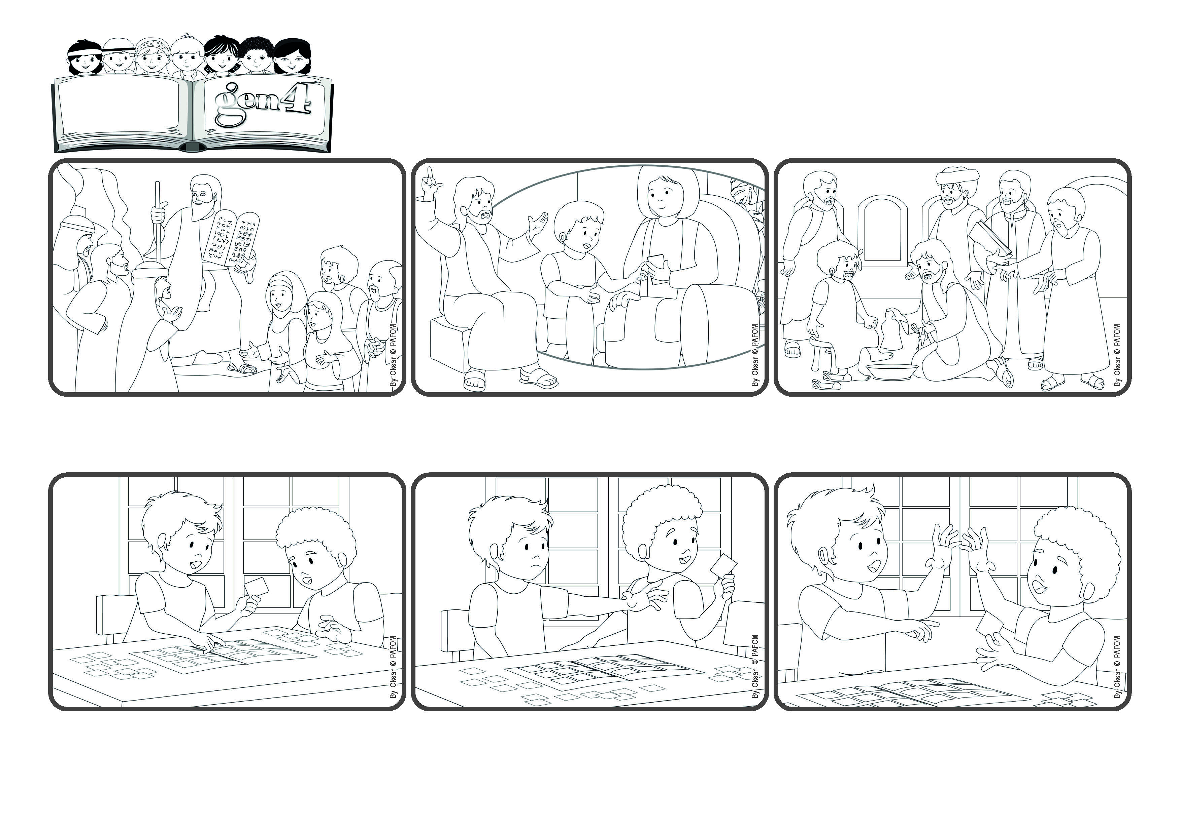

**"Be doers of the word, and not merely hearers who deceive themselves." (Jas 1:22).**

(SEPTEMBER 2024, from the liturgy of September 1, the 22nd Sunday in Ordinary Time) (From the liturgy of June 16, the Eleventh Sunday in Ordinary Time)

**Let’s love with actions and not just with words**

**Word**

**of Life**



**Jesus gave us the example by how he lived. He didn’t just talk about love - he was the first to love others. He forgave everyone. He loved everyone. And he will also help us to do the same. He asks us to love everyone around us in concrete ways.**

**Then, when Jesus came on earth, he helped us understand more about these laws. He emphasized the importance of love, which sums up all of them. And he very often explained that it’s not enough to know the commandments. We have to live them in concrete ways.**

**Do you remember when Moses went up to the top of a mountain and received the Ten Commandments from God? When he came down Moses explained to the people that by observing these commandments they would become wise, live a good life and be esteeemed by all the other nations.**

**He really didn’t want to give it up, but then he saw how happy his friend was and thought: “Even though it’s very hard to do, I can give it as an act of love.” So he told his friend: “Go ahead and take it, it’s my gift to you!” Francesco was really very happy and gave a big hug to Paolo!**

**Francesco starting looking at them and picked up one of them, saying: “This one is great! I don’t have it yet!” Paolo got upset and thought: “Oh no! That’s the one that’s almost impossible to find! It’s not a copy and I want to keep it!”**

**Francesco went to visit Paolo, his best friend. Both of them love to collect cards. Paolo was in his room and had his album on the table. He was attaching all the cards he had just bought.**

**© PAFOM, Drawings and text provided by the Gen4 Center.**

**The Gen4 are the young children of the Focolare Movement, which was founded by Chiara Lubich.**