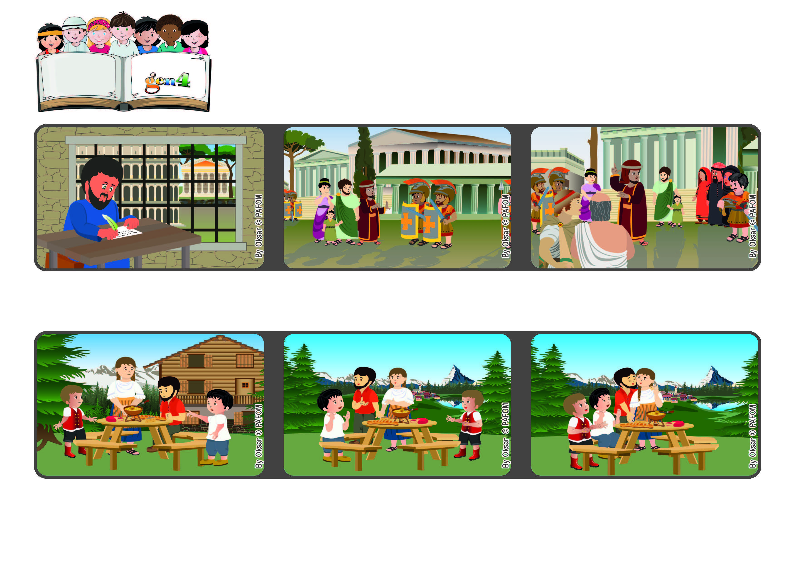

**October 2022**

**Word of Life**

**Let’s be courageous in loving**

**“God did not give us a spirit of cowardice, but rather a spirit of power**

**and of love and of self-discipline.” (2Tim 1:7)**

**© PAFOM, Drawings and text provided by the Gen4 Center.**

**The Gen4 are the young children of the Focolare Movement, which was founded by Chiara Lubich.**

**And so Paul reminded him not to be afraid, but rather to be confident since God had given him the Holy Spirit to announce the Gospel to everyone with great power, love and prudence. Through him many people would get to know Jesus.**

**Timothy was really frightened by the persecutions against Christians that were going on at that time.**

**Michele and Giuseppe live in a wooded area near the Alps Mountains. One day their parents had a heated argument and during dinner there was a lot of tension in the room.**

**But the two Gen 4 were not very convinced with their answer and so they said; “Good! Now you have to forgive each other with a kiss.” After that there was peace in their family. The experience of two Gen 4 in Switzerland**

**So one of the boys stood up and went over to his parents and said, “You two got married because you loved each other, right?” Their parents stopped talking, looked at one another and said, “Yes.” They wanted to downplay what had happened.**

**Paul the apostle was in prison in Rome. He knew he would be condemned to death and he wrote to Timothy, a young Christian who helped him a lot and was in charge of the community in Ephesus.**