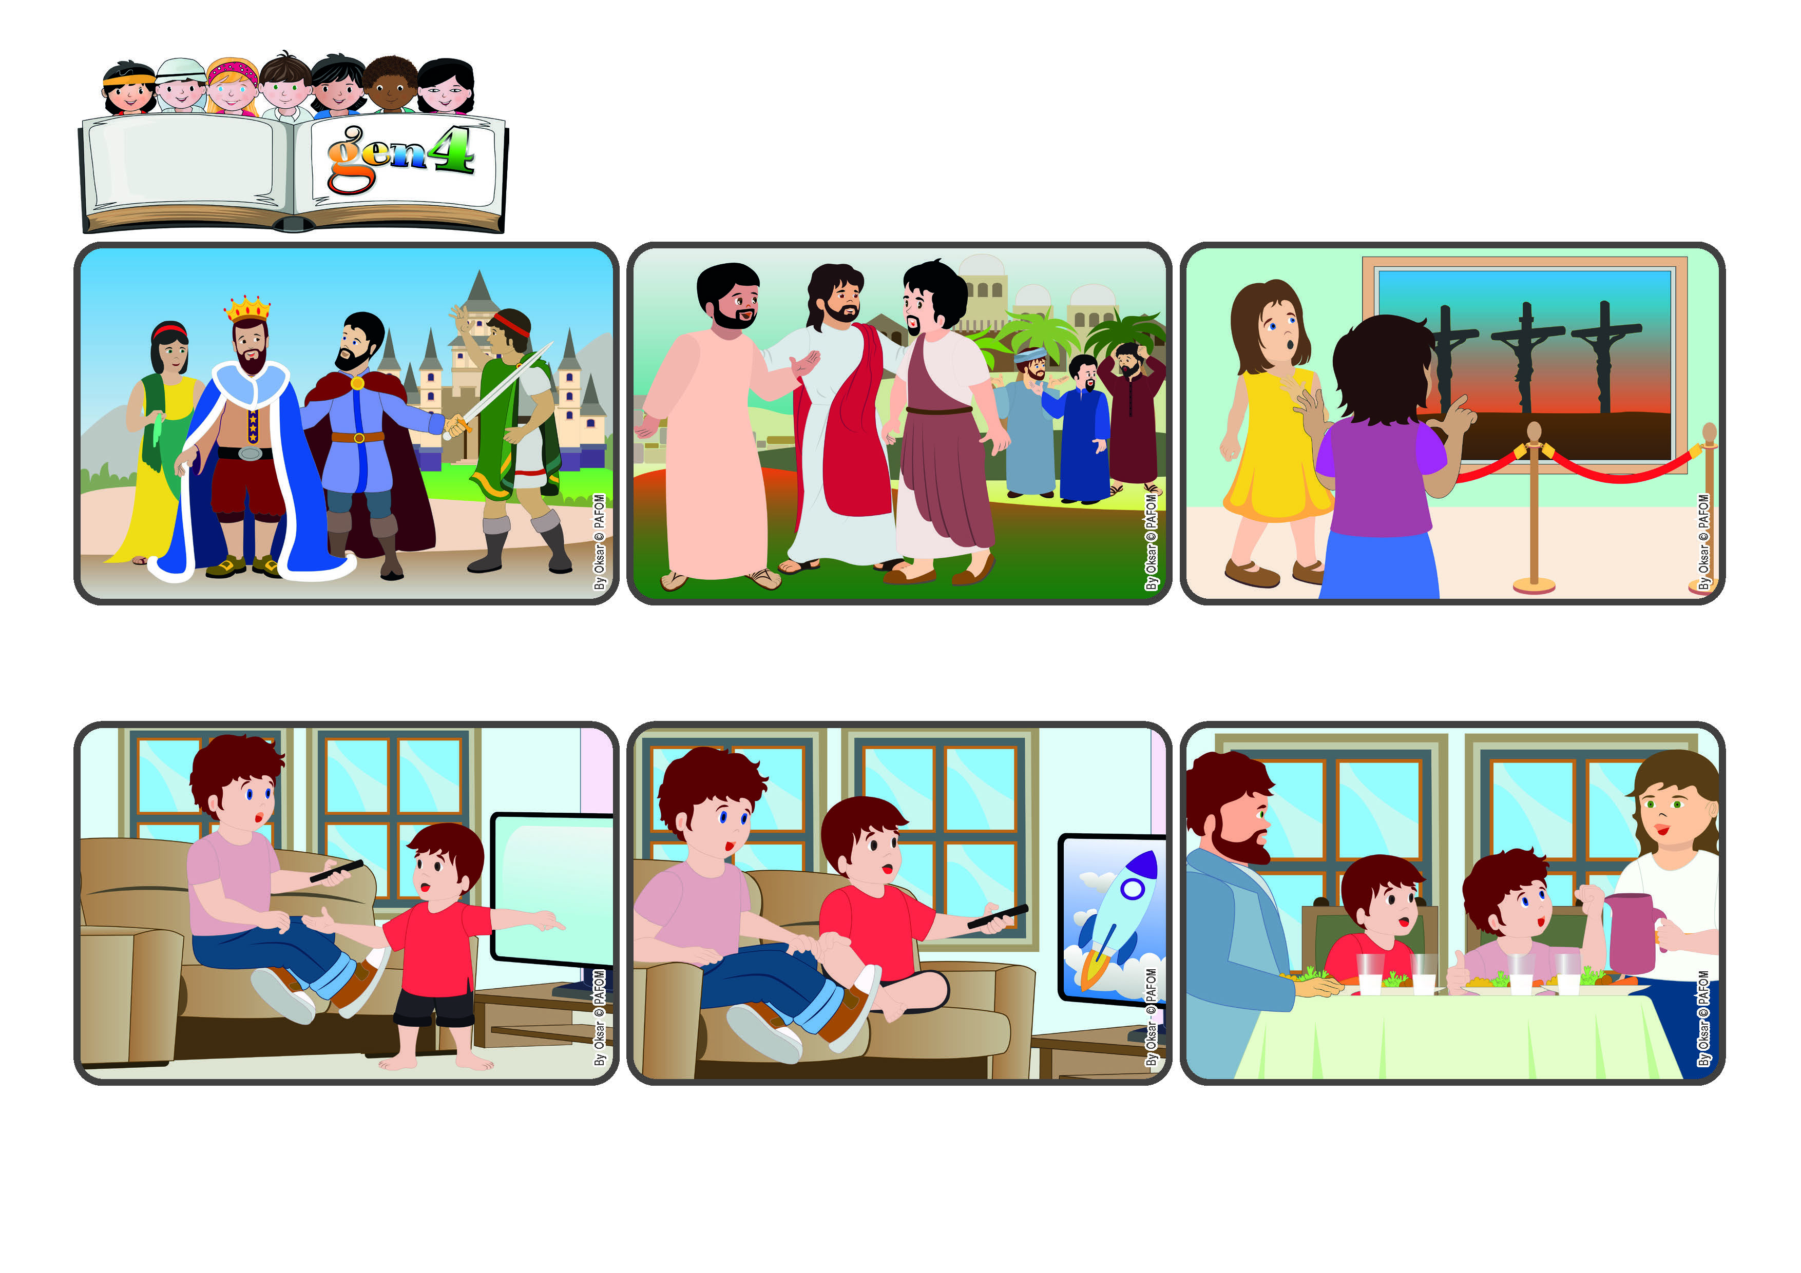

**"Whoever wishes to become great among you must be your servant, and whoever wishes to be first among you must be the slave of all." (Mk 10:43-44)**

**Word**

**of Life**

(**OCTOBER 2024**, from the liturgy of October 20, the 29th Sunday in Ordinary Time)

**The most important person is the one who loves the most**

**That evening, my mother told me: “Filippo, tomorrow they’re going to repeat that program you like so much!” “That’s great!” – I thought - “Jesus is really a gentleman!” The next day I watched the whole program and my little brother even watched it with me!**

**“That’s not fair!” I told him. “I was here first! And I’m older than you, so I get to choose!” Then I thought about it and realized this was a chance to make him happy, and so I let him watch his favorite program. And I felt even better than if I had won!**

**This afternoon I was really happy because my favorite program was on TV. I was already sitting on the couch ready to watch it when my little brother came in and said he wanted to watch something else.**

**In fact, Jesus didn’t come to order people around, but to serve them, and love them. That’s what he always did throughout his whole ife, right up to the point of dying on the cross out of love for us. He helped us understand that only by loving would we be in the first place and the most important ones.**

**One day James and John asked Jesus is they could be next to him when he was in heaven. The other disciples got upset with them about this, and so Jesus explained to them that in his kingdom, whoever wanted to be important had to serve everyone else.**

**At the time when Jesus lived, people thought that the leaders of their kingdom were the most important ones and should be respected the most because they gave orders and had many servants. That’s why many people wanted a place beside the leaders!**

**© PAFOM, Drawings and text provided by the Gen4 Center.**

**The Gen4 are the young children of the Focolare Movement, which was founded by Chiara Lubich.**