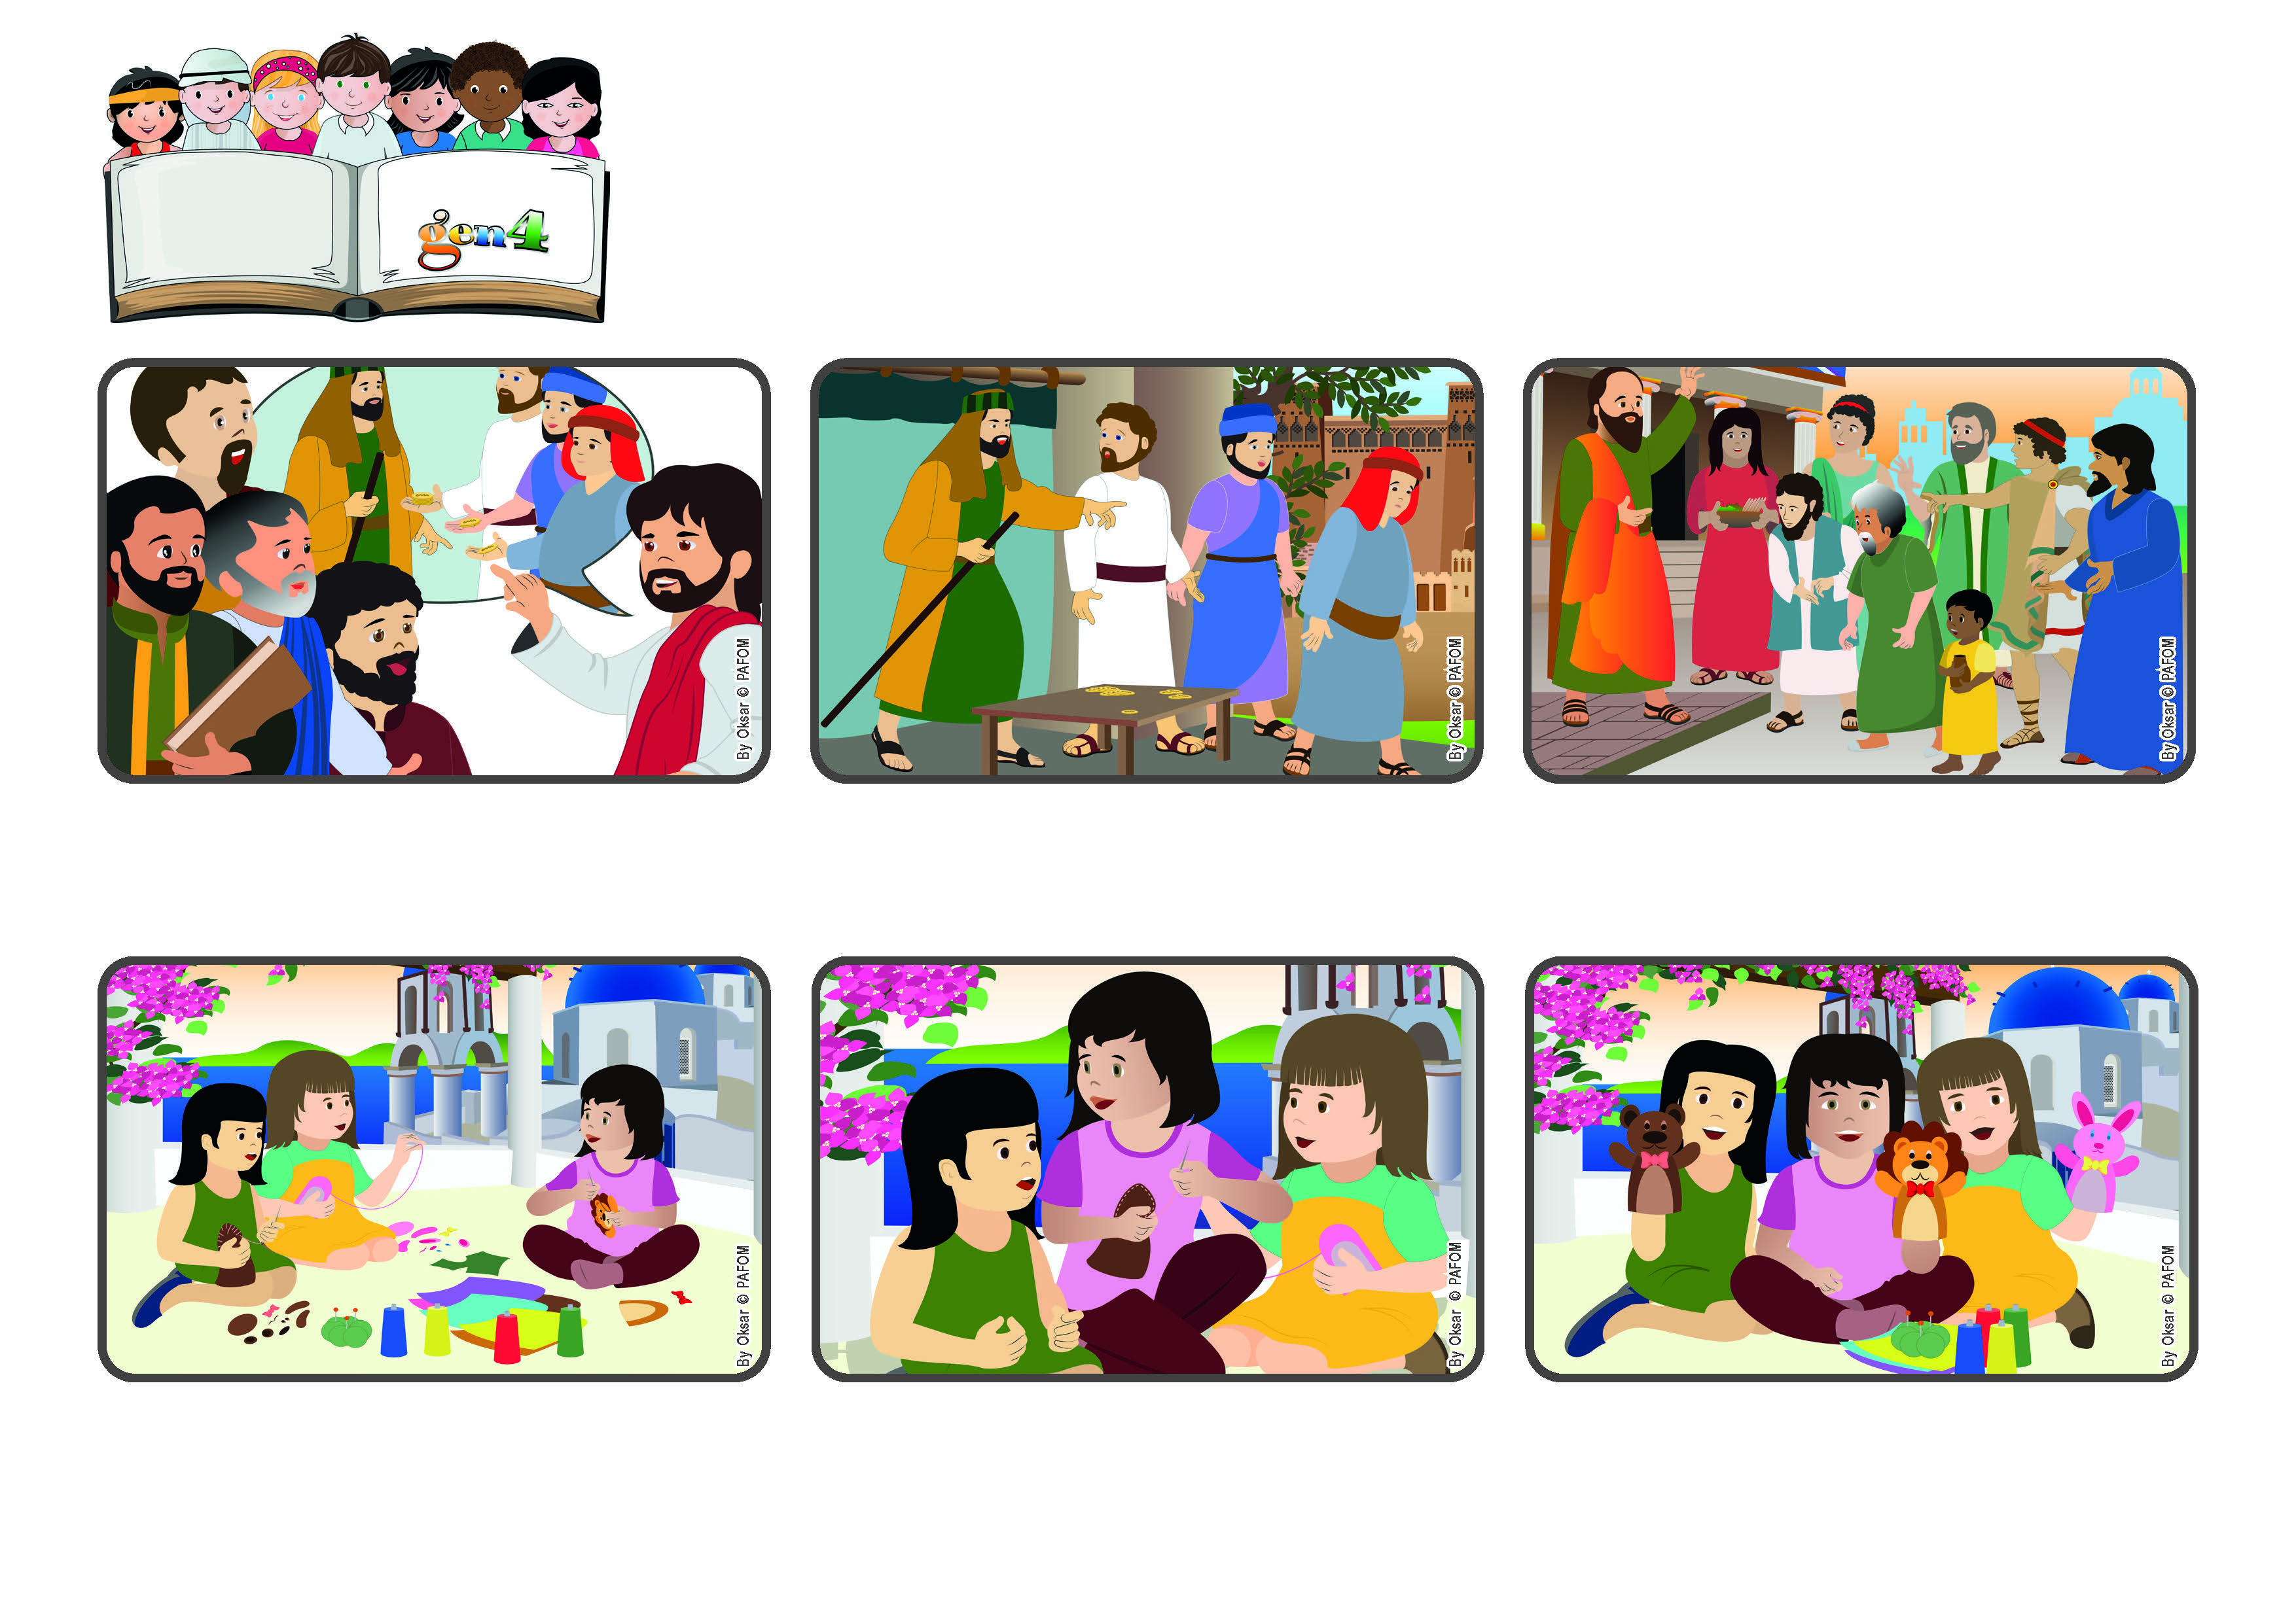

**November 2023**

**Word of Life**

**“You are all children of light and children of the day;**

**we are not of the night or of darkness.” (1Thes 5:5)**

**(From the Liturgy of the Mass on the 33rd Sunday of Ordinary Time)**

**The light of Jesus gives us the strength to love**

**In this way, my talent was multiplied! Now we had three beautiful puppets and we could make a nice puppet show with them. After I did this act of love, I felt much closer to God.**

**I was so happy about what I had done that I didn’t even realize that my friend, Antonella, was very sad because she wasn’t really good at sewing! Right away I went over to help her and I also helped my other friend, Vittoria.**

**Ariana from Greece tells her experience: During our vacation we made some handmade crafts. One day we were sewing some puppets. Mine was coming out really well because I am good at doing that. My grandma always tells me that I have a gift for sewing things well!**

**God has given each one of us different talents. It doesn’t matter if we have a lot or a few. Each one of us can make these talents bear fruit so that what God gave us will shine out for everyone. In fact, Saint Paul told the first Christians: “You are all children of the light!”**

**The third one hid his coin in a hole in the ground because he was afraid to lose it! Their master returned and praised the first two servants because they gave him back double of what they had received. Instead he scolded the third one who gave him back the one coin he had received.**

**Jesus was with his disciples. He told them a story about a man who was leaving for a long trip and he entrusted some of his money to his servants. To one he gave five coins, to another two and to the last one, he gave only one.**

**© PAFOM, Drawings and text provided by the Gen4 Center.**

**The Gen4 are the young children of the Focolare Movement, which was founded by Chiara Lubich.**